EPAM’s Snowflake Hands-on Lab

# Lab Overview

This Lab (prepared by your EPAM colleagues) offers a high-level description of the practical task for self-directed learning.

The target group for the Lab are DWBI engineers with experience in building Data Warehouses using other databases (Oracle, MS SQL, Teradata, etc.).

# Lab Data Set

Data set from [TPC-H benchmark](http://www.tpc.org/tpch/) is proposed for the Lab. TPC-H allows you to generate data for 8 tables. The data volume (in gigabytes) is defined by scale factor (SF). For the Lab purpose, you can [download](https://epam-my.sharepoint.com/:f:/p/maksim_krupenin/Ehu35G00GDVEt--YeQhrYc0BB63ueaqLIqU-zt4r9Dx4pQ?e=X12K0F) prepared in advance data set (2 GB of raw data, SF=2):

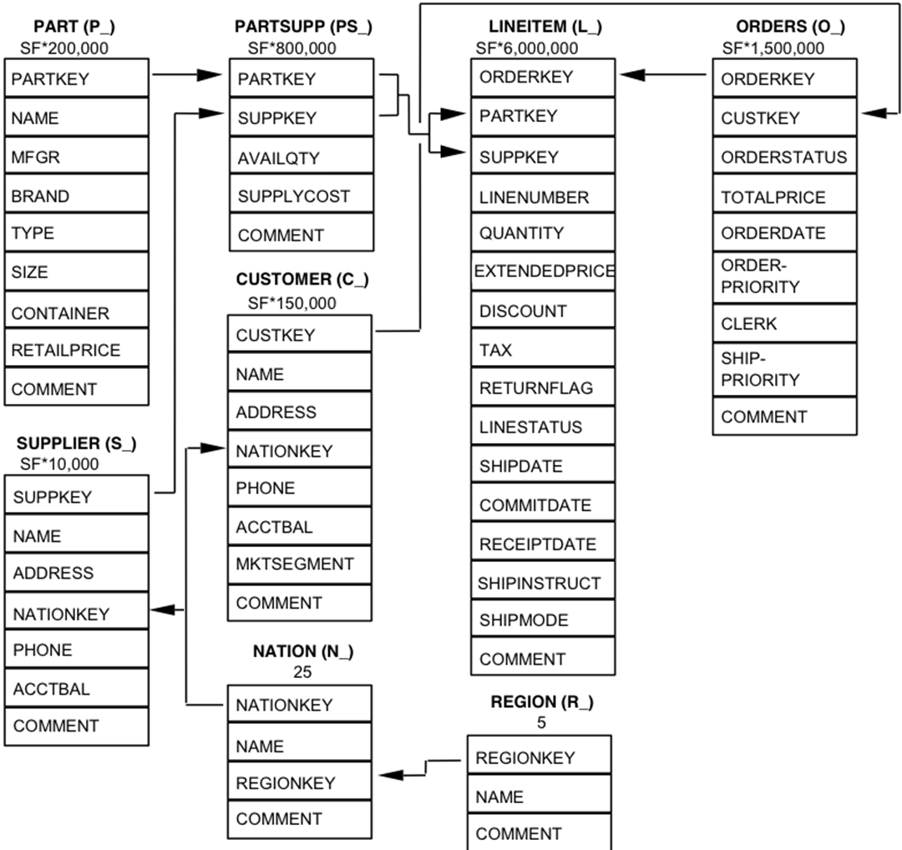

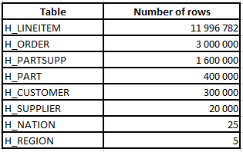

# In the shared folder, you can also find DDL script for the tables: *tpch_ddl.sql*.

# Lab Description

Hands-on-lab is considered as completed if you score >= 60 points.

(Tasks 1, 8 – 5 points each, Tasks 2, 4, 5, 6 – 10 points each, Task 3 – 30 points, Task 7 – 20 points).

## Database creation

First, you need to create a separate database EPAM_LAB in Snowflake.

## Data loading

In this step, you need to load Lab data set to an internal (Snowflake) or external stage. If you have an existing account in AWS/GCP/Azure cloud, an external stage would be preferable. Please note that you may need some data preparation steps before loading.

## ELT Data Workflow

Create two schemas in the DB you created before:

* CORE_DWH
* DATA_MART

Develop the following automated data workflow:

Stage -> CORE_DWH -> DATA_MART

Data in CORE_DWH should be modeled according to 3NF (as is - no transformation). Star Schema is a target data model for DATA_MART (data should be transformed accordingly).

The following Snowflake features should be used:

* Tasks
* Stored Procedures
* Tables Streams

*Note: No need to spend a lot of time on the modeling Star Schema implementing all nuances. You should rather focus on Snowflake’s capabilities.*

## Snowflake & 3rd party tools

When the data is loaded to DATA_MART schema, connect Snowflake as a data source from any BI tool (Tableau, PowerBI, Qlik Sense, etc.) and create a simple dashboard.

Also, try connecting to Snowflake from any SQL editor (e.g. [DBeaver](https://dbeaver.io/)).

1. Snowflake SQL

From the shared folder you can also [download](https://epam-my.sharepoint.com/:f:/p/maksim_krupenin/Ehu35G00GDVEt--YeQhrYc0BB63ueaqLIqU-zt4r9Dx4pQ?e=X12K0F) the file with 22 TPC-H benchmarking queries (tpch_benchmark_queries.sql). Please note that the queries were modified to execute in AWS RedShift database, so some of them may require modifications for Snowflake. Use the queries to test how Snowflake works:

* Create several warehouses of different sizes and compare their performance.
* Test how Snowflake leverages different types of cash.
* Rewrite a couple of queries to execute on the Start Schema data model and compare performance (3NF vs Star Schema).
* Execute queries using SnowSQL (CLI Client).

## Other Snowflake features

Learn and test other interesting Snowflake features:

* Object Cloning
* Time Travel
* Data Sharing - share your DATA_MART schema with a colleague who helps you with this Lab. Also, you may use a [Reader Account](https://docs.snowflake.com/en/user-guide/data-sharing-reader-create.html).

## Snowpipe

Automated incremental data loading using Snowpipe. Split lineitem & order files into several parts and simulate their sequential loading to stage buckets.

## Additional tasks

Connect your Snowflake account with partner applications available for a free trial (e.g. Fivetran, Periscope Data, Matillion in Partner Connect menu). Explore how selected tools work.

## Database creation.

use role accountadmin;

create database epam_lab;

drop schema public;

use database epam_lab;

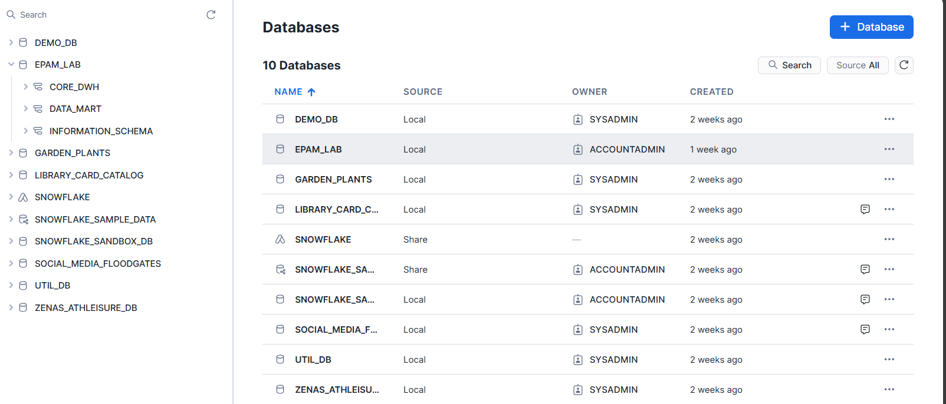

## Data loading.

CREATE STAGE epam_lab_stage

ENCRYPTION = (TYPE = 'SNOWFLAKE_SSE');

ALTER STAGE epam_lab_stage

SET DIRECTORY = ( ENABLE = TRUE );

tpch_data>snow stage list

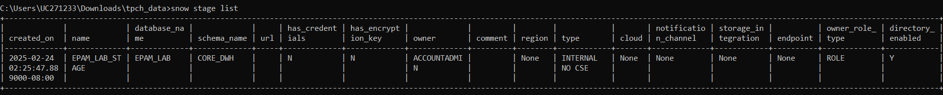

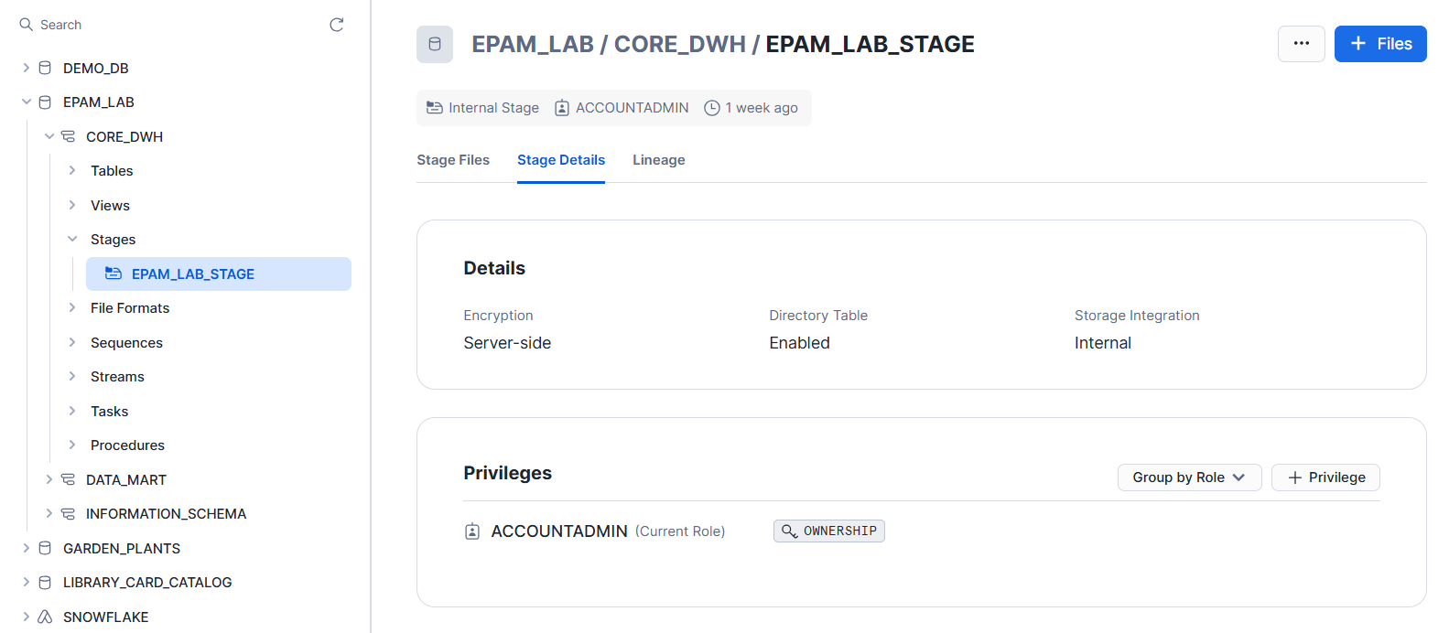

tpch_data>dir tcph2data\*

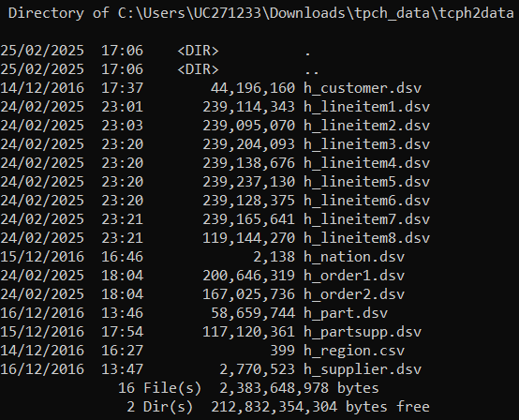

tpch_data>snow stage copy tcph2data/ @EPAM_LAB_STAGE --overwrite

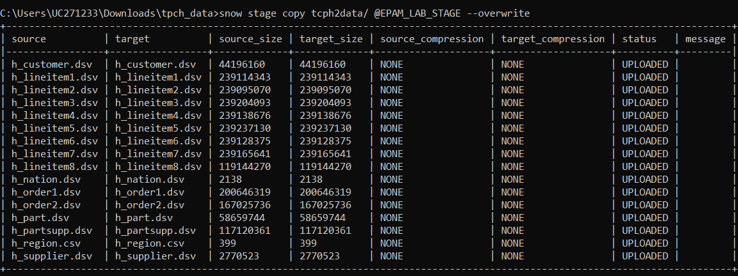

tpch_data>snow stage list-files @EPAM_LAB_STAGE

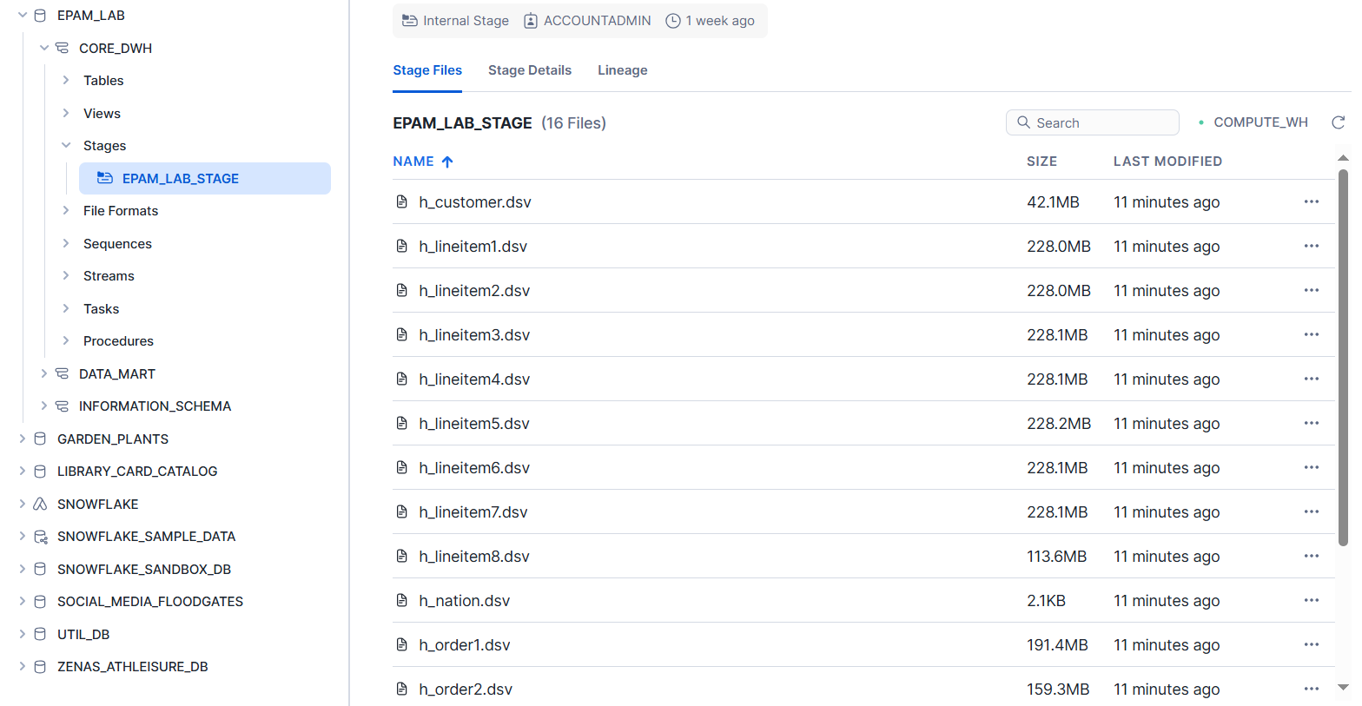

## ELT Data Workflow

* **Create schemas**

use database epam_lab;

create schema core_dwh;

create schema data_mart;

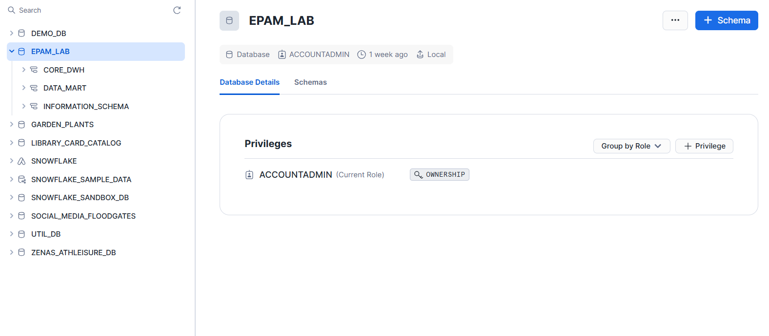

* **Create format files**

use schema core_dwh;

create or replace file format COMMCOLSEP_ONEHEADROW

type = 'CSV'

field_delimiter = ','

skip_header = 1

field_optionally_enclosed_by = '"'

trim_space = TRUE;

create or replace file format PIPECOLSEP_ONEHEADROW

type = 'CSV'

field_delimiter = '|'

skip_header = 1

field_optionally_enclosed_by = '"'

trim_space = TRUE;

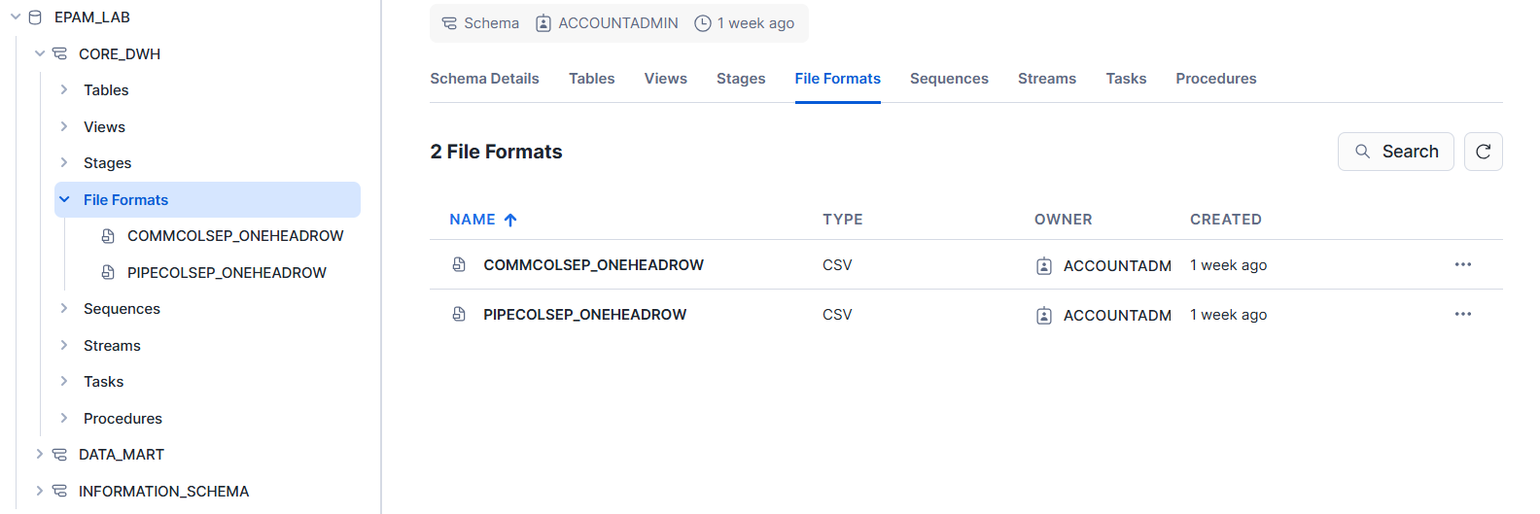

* **Check format files on stage files**

select $1, $2 from @EPAM_LAB.CORE_DWH.EPAM_LAB_STAGE/h_nation.dsv;

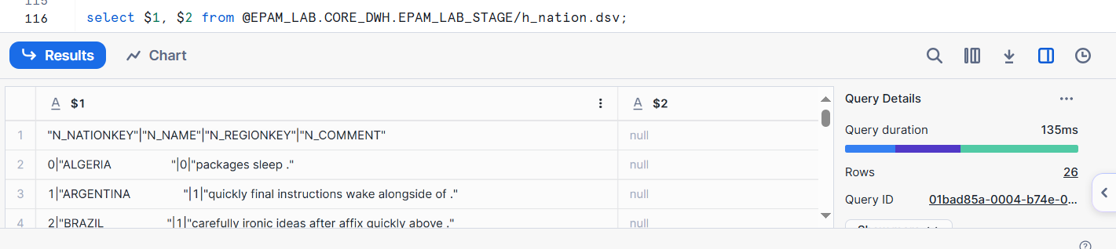

select $1, $2 from @EPAM_LAB.CORE_DWH.EPAM_LAB_STAGE/h_nation.dsv

(file_format => PIPECOLSEP_ONEHEADROW);

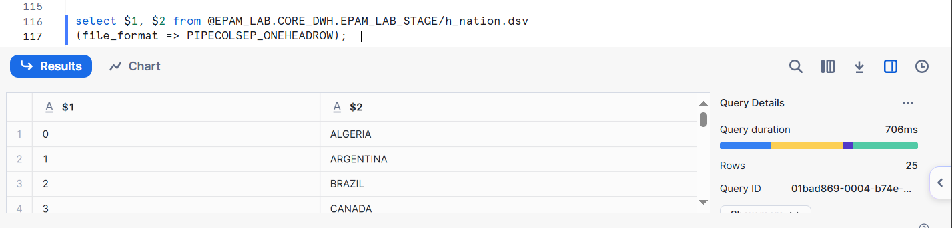

select $1, $2 from @EPAM_LAB.CORE_DWH.EPAM_LAB_STAGE/h_region.csv;

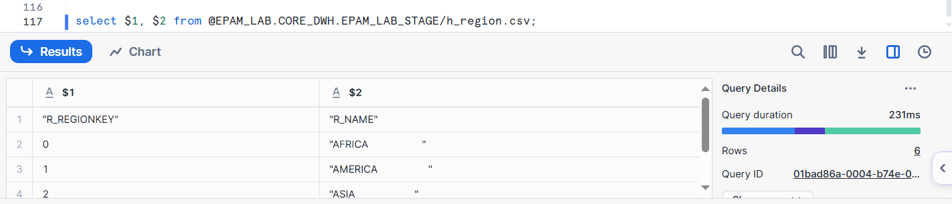

select $1, $2 from @EPAM_LAB.CORE_DWH.EPAM_LAB_STAGE/h_region.csv

(file_format => COMMCOLSEP_ONEHEADROW);

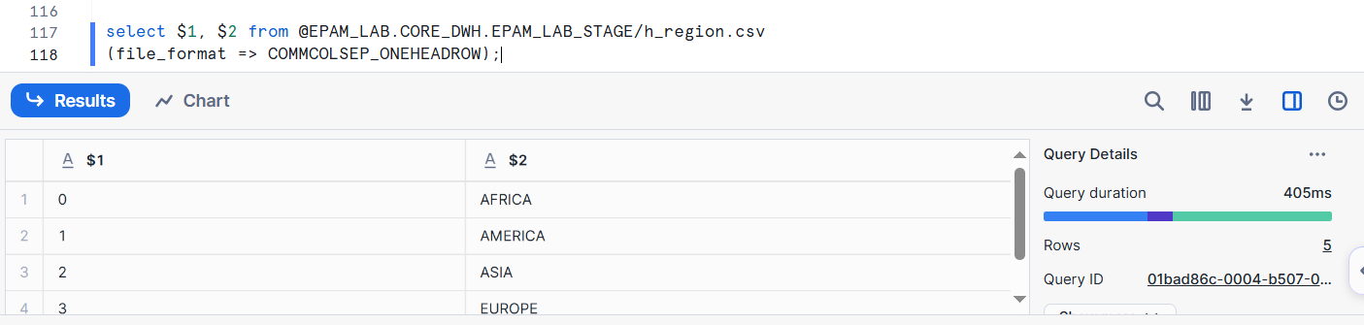

* **Create tables in CORE_DWH schema.**

use schema core_dwh;

drop table if exists region;

create table region

(

r_regionkey NUMBER not null,

r_name VARCHAR(25),

r_comment VARCHAR(152)

);

drop table if exists nation;

create table nation

(

n_nationkey NUMBER not null,

n_name VARCHAR(27),

n_regionkey NUMBER,

n_comment VARCHAR(155)

);

drop table if exists supplier;

create table supplier

(

s_suppkey NUMBER not null,

s_name VARCHAR(25),

s_address VARCHAR(40),

s_nationkey NUMBER,

s_phone VARCHAR(15),

s_acctbal FLOAT,

s_comment VARCHAR(101)

);

drop table if exists orders;

create table orders

(

o_orderkey NUMBER not null,

o_custkey NUMBER not null,

o_orderstatus VARCHAR(1),

o_totalprice FLOAT,

o_orderdate DATE,

o_prioritykey NUMBER(2),

o_clerk VARCHAR(15),

o_shippriority NUMBER(2),

o_comment VARCHAR(79)

);

drop table if exists partsupp;

create table partsupp

(

ps_partkey NUMBER not null,

ps_suppkey NUMBER not null,

ps_availqty NUMBER,

ps_supplycost FLOAT not null,

ps_comment VARCHAR(199)

);

drop table if exists part;

create table part

(

p_partkey NUMBER not null,

p_name VARCHAR(55),

p_mnfgrkey NUMBER(5),

p_brandkey NUMBER(5),

p_pcktpkey NUMBER(5),

p_size NUMBER,

p_cntnrkey NUMBER(5),

p_retailprice NUMBER,

p_comment VARCHAR(23)

);

drop table if exists customer;

create table customer

(

c_custkey NUMBER not null,

c_name VARCHAR(25),

c_address VARCHAR(40),

c_nationkey NUMBER,

c_phone VARCHAR(15),

c_acctbal FLOAT,

c_segmentkey NUMBER(5),

c_comment VARCHAR(117)

);

drop table if exists lineitem;

create table lineitem

(

l_orderkey NUMBER not null,

l_partkey NUMBER not null,

l_suppkey NUMBER not null,

l_linenumber NUMBER not null,

l_quantity NUMBER not null,

l_extendedprice FLOAT not null,

l_discount FLOAT not null,

l_tax FLOAT not null,

l_returnflag VARCHAR(1),

l_linestatus VARCHAR(1),

l_shipdate DATE,

l_commitdate DATE,

l_receiptdate DATE,

l_shipinstruct VARCHAR(25),

l_shipmode VARCHAR(10),

l_comment VARCHAR(44)

);

drop table if exists ordpriority;

create table ordpriority

(

p_prioritykey number(2) not null,

p_priorityname varchar(80) not null

);

drop table if exists mktsegment;

create table mktsegment

(

m_segmentkey number(5) not null,

m_segmentname varchar(80) not null

);

drop table if exists brand;

create table brand

(

b_brandkey number(5) not null,

b_brandname varchar(80) not null

);

drop table if exists manufacture;

create table manufacture

(

m_mnfgrkey number(5) not null,

m_mnfgrname varchar(80) not null

);

drop table if exists container;

create table container

(

c_cntnrkey number(5) not null,

c_cntnrname varchar(80) not null

);

drop table if exists packagetype;

create table packagetype

(

p_pcktpkey number(5) not null,

p_pcktpname varchar(80) not null

);

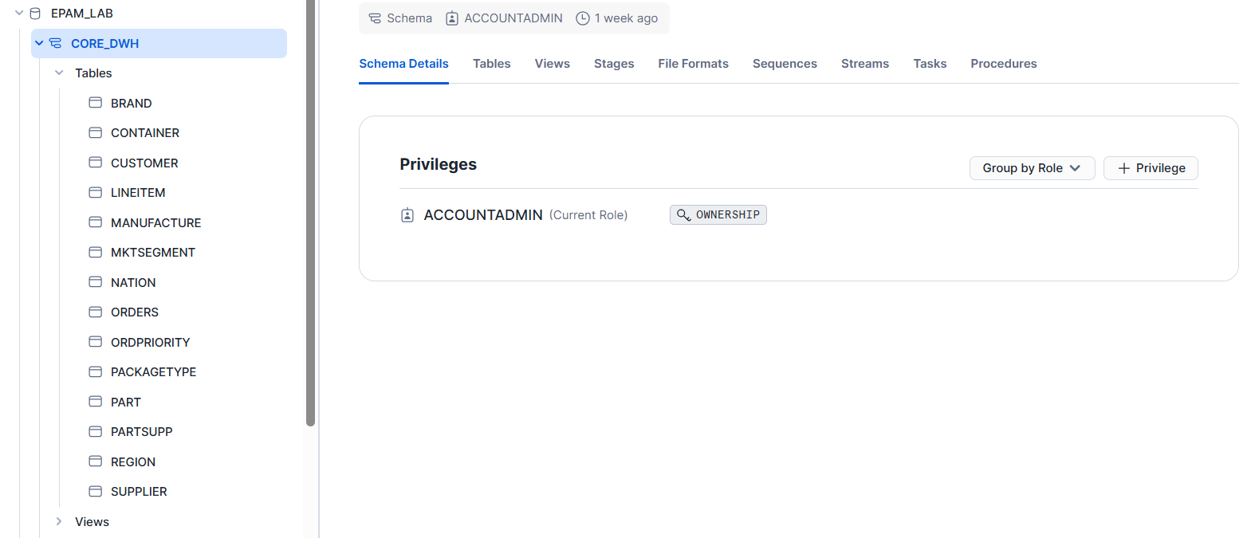

* **Create Stage Views in CORE_DWH schema.**

use database epam_lab;

use schema core_dwh;

create or replace view h_mktsegment_v as

select distinct trim($7) C_MKTSEGMENT

from @EPAM_LAB.CORE_DWH.EPAM_LAB_STAGE/h_customer.dsv

(file_format => PIPECOLSEP_ONEHEADROW )

order by C_MKTSEGMENT;

create or replace view h_customer_v as

select C_CUSTKEY, C_NAME, C_ADDRESS, C_NATIONKEY, C_PHONE, C_ACCTBAL, M_SEGMENTKEY, C_COMMENT

from

(

select $1 C_CUSTKEY, $2 C_NAME, $3 C_ADDRESS, $4 C_NATIONKEY,

$5 C_PHONE, replace($6, ',', '.') C_ACCTBAL, trim($7) C_MKTSEGMENT, $8 C_COMMENT

from @EPAM_LAB.CORE_DWH.EPAM_LAB_STAGE/h_customer.dsv(file_format => PIPECOLSEP_ONEHEADROW)

) r inner join mktsegment

on M_SEGMENTNAME = C_MKTSEGMENT

order by C_CUSTKEY;

create or replace view h_supplier_v as

select $1 S_SUPPKEY, $2 S_NAME, $3 S_ADDRESS, $4 S_NATIONKEY,

$5 S_PHONE, replace($6, ',', '.') S_ACCTBAL, $7 S_COMMENT

from @EPAM_LAB.CORE_DWH.EPAM_LAB_STAGE/h_supplier.dsv

(file_format => PIPECOLSEP_ONEHEADROW );

create or replace view h_order_v as

select $1 O_ORDERKEY, $2 O_CUSTKEY, $3 O_ORDERSTATUS, replace($4, ',', '.') O_TOTALPRICE,

date($5, 'dd.mm.yy') O_ORDERDATE, substring($6,1, position('-' in $6)-1) O_PRIORITYKEY,

$7 O_CLERK, $8 O_SHIPPRIORITY, $9 O_COMMENT

from @EPAM_LAB.CORE_DWH.EPAM_LAB_STAGE

( file_format => PIPECOLSEP_ONEHEADROW, pattern=>'h_order.*[.]dsv' );

create or replace view h_ordpriority_v as

select distinct substring($6,1, position('-' in $6)-1) O_PRIORITYKEY,

substring($6,position('-' in $6)+1) O_PRIORITYNAME

from @EPAM_LAB.CORE_DWH.EPAM_LAB_STAGE

( file_format => PIPECOLSEP_ONEHEADROW, pattern=>'h_order.*[.]dsv' );

create or replace view h_lineitem_v as

select $1 L_ORDERKEY, $2 L_PARTKEY, $3 L_SUPPKEY, $4 L_LINENUMBER, $5 L_QUANTITY,

replace($6, ',', '.') L_EXTENDEDPRICE, replace($7, ',', '.') L_DISCOUNT,

replace($8, ',', '.') L_TAX, $9 L_RETURNFLAG, $10 L_LINESTATUS, date($11, 'dd.mm.yy') L_SHIPDATE,

date($12, 'dd.mm.yy') L_COMMITDATE, date($13, 'dd.mm.yy') L_RECEIPTDATE,

$14 L_SHIPINSTRUCT, $15 L_SHIPMODE, $16 L_COMMENT

from @EPAM_LAB.CORE_DWH.EPAM_LAB_STAGE

( file_format => PIPECOLSEP_ONEHEADROW, pattern=>'h_lineitem.*[.]dsv' );

create or replace view h_partsupp_v as

select $1 PS_PARTKEY, $2 PS_SUPPKEY, $3 PS_AVAILQTY,

replace($4, ',', '.') PS_SUPPLYCOST, $5 PS_COMMENT

from @EPAM_LAB.CORE_DWH.EPAM_LAB_STAGE

( file_format => PIPECOLSEP_ONEHEADROW, pattern=>'h_partsupp.*[.]dsv' );

create or replace view h_mfrgr_v as

select distinct trim($3) m_mfrgrname

from @EPAM_LAB.CORE_DWH.EPAM_LAB_STAGE

( file_format => PIPECOLSEP_ONEHEADROW, pattern=>'h_part.dsv' );

create or replace view h_brand_v as

select distinct trim($4) b_brandname

from @EPAM_LAB.CORE_DWH.EPAM_LAB_STAGE

( file_format => PIPECOLSEP_ONEHEADROW, pattern=>'h_part.dsv' );

create or replace view h_container_v as

select distinct trim($7) c_cntrname

from @EPAM_LAB.CORE_DWH.EPAM_LAB_STAGE

( file_format => PIPECOLSEP_ONEHEADROW, pattern=>'h_part.dsv' );

create or replace view h_package_v as

select distinct trim($5) p_packname

from @EPAM_LAB.CORE_DWH.EPAM_LAB_STAGE

( file_format => PIPECOLSEP_ONEHEADROW, pattern=>'h_part.dsv' );

create or replace view h_part_v as

select P_PARTKEY, P_NAME, M_MNFGRKEY, B_BRANDKEY, P_PCKTPKEY, P_SIZE,

C_CNTNRKEY, P_RETAILPRICE, P_COMMENT

from

(

select $1 P_PARTKEY, trim($2) P_NAME, trim($3) P_MFGR, trim($4) P_BRAND, trim($5) P_TYPE,

$6 P_SIZE, trim($7) P_CONTAINER, $8 P_RETAILPRICE, $9 P_COMMENT

from @EPAM_LAB.CORE_DWH.EPAM_LAB_STAGE

( file_format => PIPECOLSEP_ONEHEADROW, pattern=>'h_part.dsv' )

)

inner join manufacture on m_mnfgrname = P_MFGR

inner join brand on b_brandname = P_BRAND

inner join packagetype on p_pcktpname = P_TYPE

inner join container on c_cntnrname = P_CONTAINER;

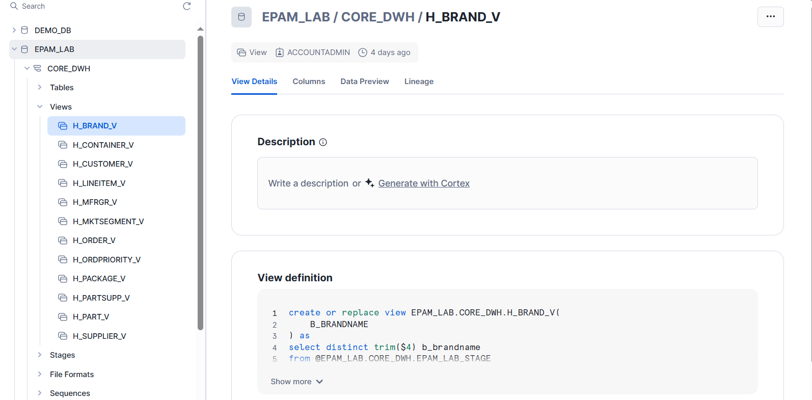

select top 10 * from h_order_v;

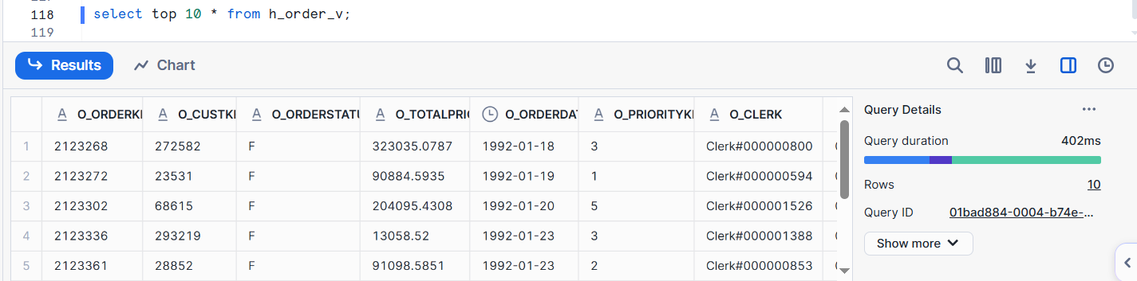

select top 10 * from h_supplier_v;

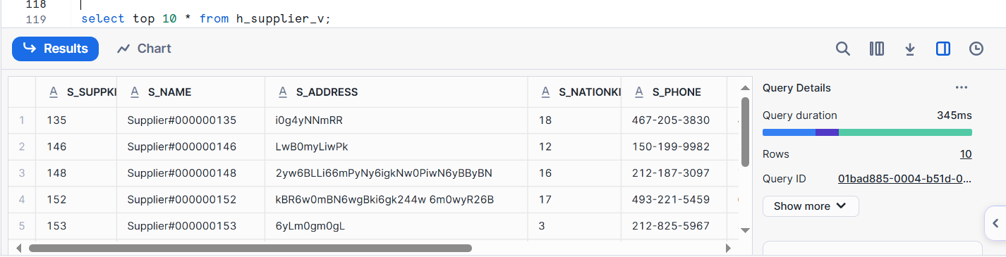

* **Create load procedures in CORE_DWH.**

create or replace procedure sp_load_csv (table_name varchar, file_name varchar)

returns integer not null

language sql

as

$$

begin

COPY INTO identifier(:table_name)

FROM @EPAM_LAB.CORE_DWH.EPAM_LAB_STAGE

PATTERN = :file_name

FILE_FORMAT = ( format_name = COMMCOLSEP_ONEHEADROW TRIM_SPACE = TRUE)

FORCE = TRUE;

return (select count(*) from identifier(:table_name));

end;

$$;

create or replace procedure sp_load_dsv (table_name varchar, file_name varchar)

returns integer not null

language sql

as

$$

begin

COPY INTO identifier(:table_name)

FROM @EPAM_LAB.CORE_DWH.EPAM_LAB_STAGE

PATTERN = :file_name

FILE_FORMAT = ( format_name = PIPECOLSEP_ONEHEADROW TRIM_SPACE = TRUE)

FORCE = TRUE;

return (select count(*) from identifier(:table_name));

end;

$$;

create or replace procedure sp_load_view (table_name varchar, view_name varchar)

returns integer not null

language sql

as

$$

begin

truncate table identifier(:table_name);

INSERT INTO identifier(:table_name)

SELECT * FROM identifier(:view_name);

return (select count(*) from identifier(:table_name));

end;

$$;

create or replace procedure sp_load_region()

returns integer not null

language sql

as

$$

BEGIN

truncate table epam_lab.core_dwh.region;

copy into region

from (select $1::int, trim($2::text), trim($3::text)

from @EPAM_LAB.CORE_DWH.EPAM_LAB_STAGE)

files = ('h_region.csv')

file_format = ( format_name=COMMCOLSEP_ONEHEADROW );

return SQLROWCOUNT;

END;

$$;

create or replace procedure sp_load_nation()

returns integer not null

language sql

as

$$

BEGIN

truncate table epam_lab.core_dwh.nation;

copy into nation

from (select $1::int, trim($2::text), $3::int, trim($4::text)

from @EPAM_LAB.CORE_DWH.EPAM_LAB_STAGE)

files = ('h_nation.dsv')

file_format = ( format_name=PIPECOLSEP_ONEHEADROW );

return SQLROWCOUNT;

END;

$$;

create or replace procedure sp_load_customer()

returns integer not null

language sql

as

$$

DECLARE

row_count INTEGER DEFAULT 0;

BEGIN

truncate table epam_lab.core_dwh.mktsegment;

insert into epam_lab.core_dwh.mktsegment

select ROW_NUMBER() OVER (order by c_mktsegment), c_mktsegment

from epam_lab.core_dwh.h_mktsegment_v;

call sp_load_view(

table_name => 'customer',

view_name => 'h_customer_v') into row_count;

return row_count;

END;

$$;

create or replace procedure sp_load_order()

returns integer not null

language sql

as

$$

DECLARE

row_count INTEGER DEFAULT 0;

BEGIN

truncate table epam_lab.core_dwh.ordpriority;

insert into epam_lab.core_dwh.ordpriority

select * from epam_lab.core_dwh.h_ordpriority_v;

call sp_load_view(

table_name => 'orders',

view_name => 'h_order_v') into row_count;

return row_count;

END;

$$;

create or replace procedure sp_load_part()

returns integer not null

language sql

as

$$

DECLARE

row_count INTEGER DEFAULT 0;

BEGIN

truncate table epam_lab.core_dwh.brand;

insert into epam_lab.core_dwh.brand

select ROW_NUMBER() OVER (order by b_brandname), b_brandname

from epam_lab.core_dwh.h_brand_v;

truncate table epam_lab.core_dwh.container;

insert into epam_lab.core_dwh.container

select ROW_NUMBER() OVER (order by c_cntrname), c_cntrname

from epam_lab.core_dwh.h_container_v;

truncate table epam_lab.core_dwh.manufacture;

insert into epam_lab.core_dwh.manufacture

select ROW_NUMBER() OVER (order by m_mfrgrname), m_mfrgrname

from epam_lab.core_dwh.h_mfrgr_v;

truncate table epam_lab.core_dwh.packagetype;

insert into epam_lab.core_dwh.packagetype

select ROW_NUMBER() OVER (order by p_packname), p_packname

from epam_lab.core_dwh.h_package_v;

call sp_load_view(

table_name => 'part',

view_name => 'h_part_v') into row_count;

return row_count;

END;

$$;

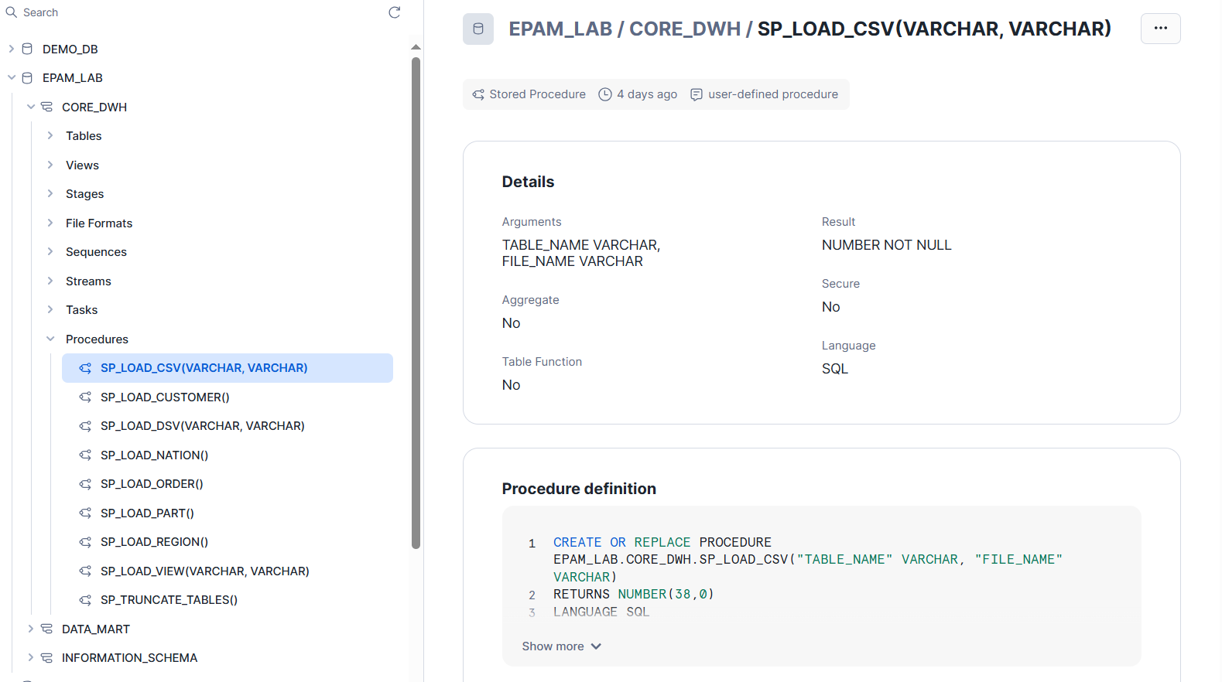

* **Data loading into CORE_DWH.**

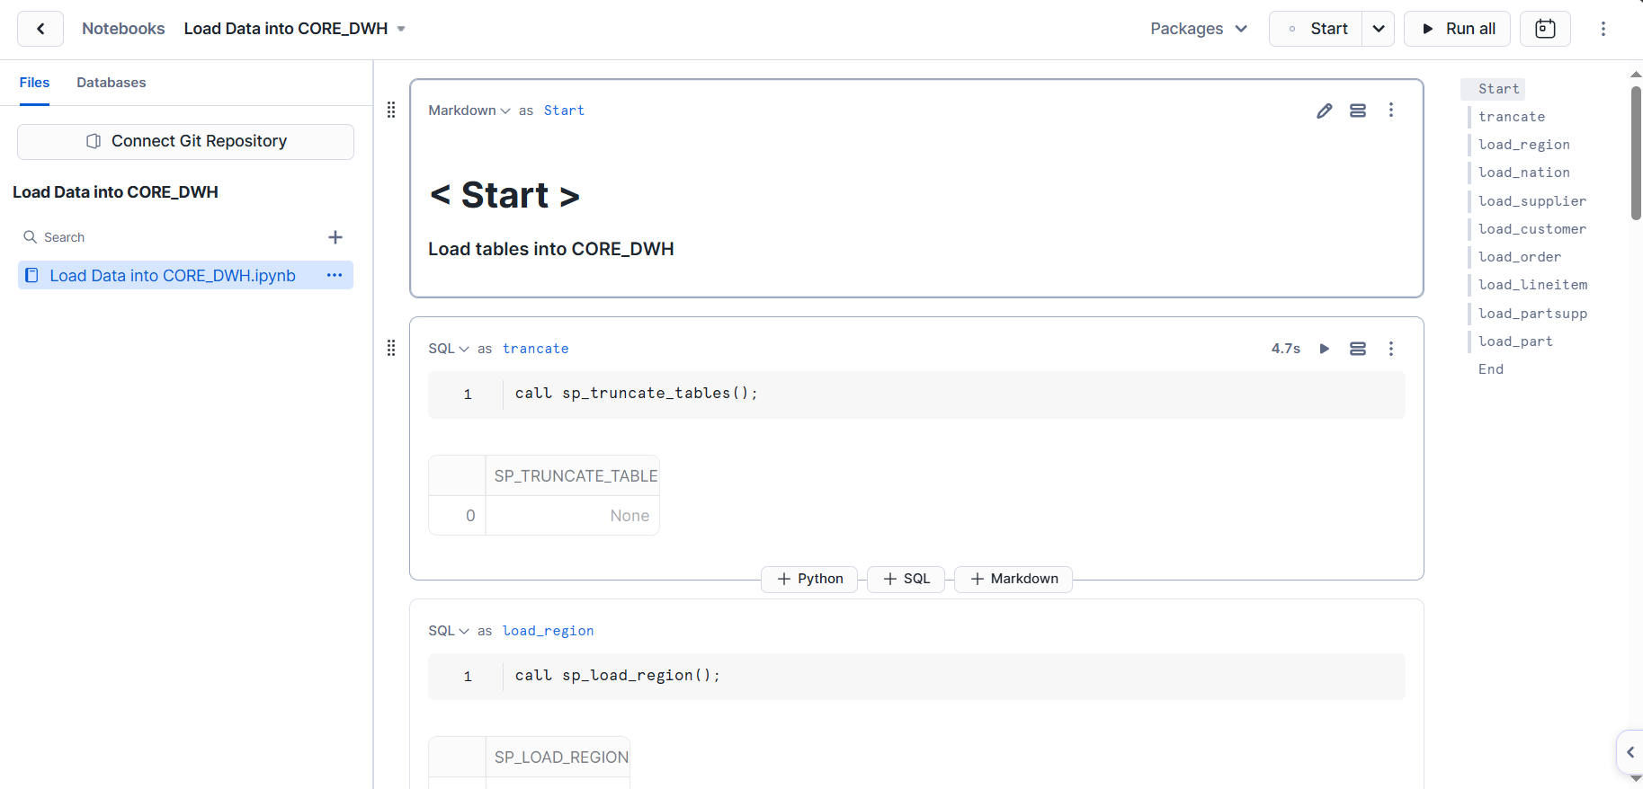

call sp_truncate_tables();

call sp_load_region();

call sp_load_nation();

call sp_load_view(

table_name => 'supplier',

view_name => 'h_supplier_v');

call sp_load_customer();

call sp_load_order();

call sp_load_view(

table_name => 'lineitem',

view_name => 'h_lineitem_v');

call sp_load_view(

table_name => 'partsupp',

view_name => 'h_partsupp_v');

call sp_load_part();

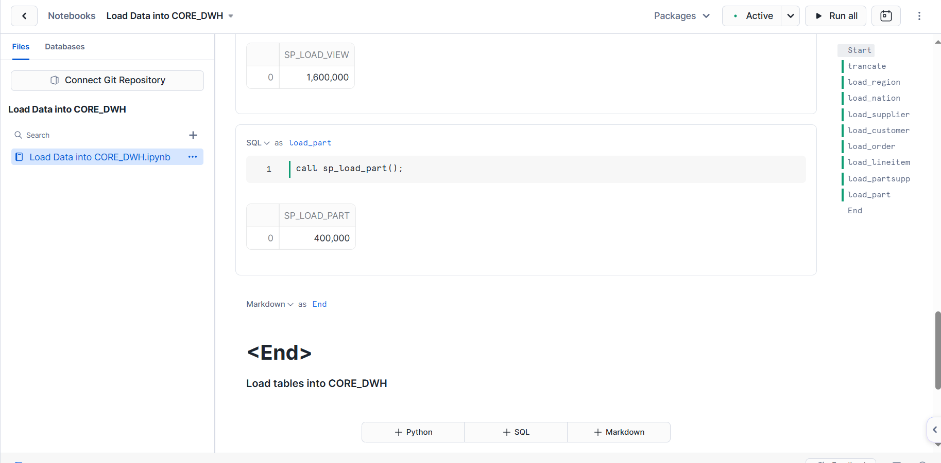

* **Check loaded data**

select source, row_num, expected,

case when row_num = expected then 'OK' else 'Error' end passed

from

(

SELECT 'H_LINEITEM' as source, count(*) as row_num, 11996782 expected

FROM epam_lab.core_dwh.lineitem

UNION ALL

SELECT 'H_ORDER', count(*), 3000000

FROM epam_lab.core_dwh.orders

UNION ALL

SELECT 'H_PARTSUPP', count(*), 1600000

FROM epam_lab.core_dwh.partsupp

UNION ALL

SELECT 'H_PART', count(*), 400000

FROM epam_lab.core_dwh.part

UNION ALL

SELECT 'H_CUSTOMER', count(*), 300000

FROM epam_lab.core_dwh.customer

UNION ALL

SELECT 'H_SUPPLIER', count(*), 20000

FROM epam_lab.core_dwh.supplier

UNION ALL

SELECT 'H_NATION', count(*), 25

FROM epam_lab.core_dwh.nation

UNION ALL

SELECT 'H_REGION', count(*), 5

FROM epam_lab.core_dwh.region

);

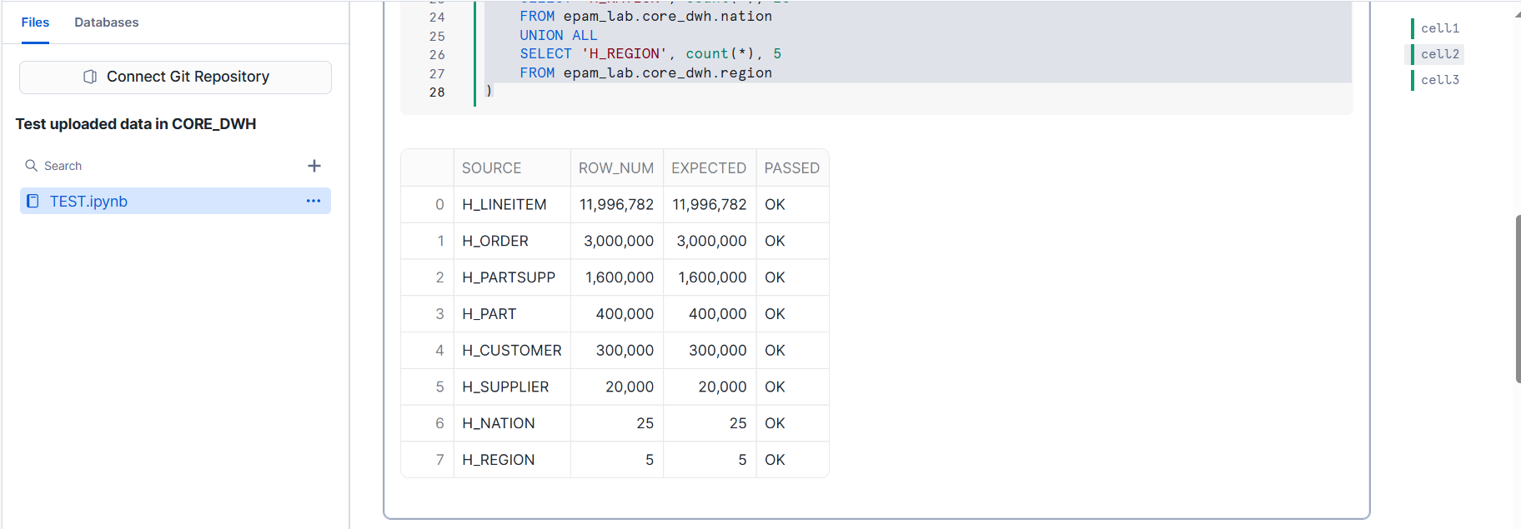

* **Create DataMart tables**

create or replace TABLE EPAM_LAB.DATA_MART.DIM_BRAND

(

B_BRANDKEY NUMBER(5,0),

B_BRANDNAME VARCHAR(80)

);

create or replace TABLE EPAM_LAB.DATA_MART.DIM_CALENDAR

(

C_CALNKEY VARCHAR(16777216),

C_CALNDATE DATE,

C_YEARNUM NUMBER(4,0),

C_QUARTER NUMBER(2,0),

C_MONTHNUM NUMBER(2,0),

C_MONTHNAME VARCHAR(3),

C_WEEKNUM NUMBER(2,0),

C_DAYWEEK NUMBER(2,0),

C_DAYNAME VARCHAR(3)

);

create or replace TABLE EPAM_LAB.DATA_MART.DIM_CONTAINER

(

C_CNTNRKEY NUMBER(5,0),

C_CNTNRNAME VARCHAR(80)

);

create or replace TABLE EPAM_LAB.DATA_MART.DIM_CUSTOMER

(

C_CUSTKEY NUMBER(38,0),

C_NAME VARCHAR(25),

C_ADDRESS VARCHAR(40),

UPDATE_TIMESTAMP TIMESTAMP_LTZ(9) default CURRENT_TIMESTAMP()::TIMESTAMP_LTZ

);

create or replace TABLE EPAM_LAB.DATA_MART.DIM_CUST_UPD

(

C_CUSTKEY NUMBER(38,0),

C_NAME VARCHAR(25),

C_ADDRESS VARCHAR(40),

START_TIME TIMESTAMP_NTZ(9),

END_TIME TIMESTAMP_NTZ(9),

CURRENT_FLAG NUMBER(38,0)

);

create or replace TABLE EPAM_LAB.DATA_MART.DIM_MKTSEGMENT

(

M_SEGMENTKEY NUMBER(5,0),

M_SEGMENTNAME VARCHAR(80)

);

create or replace TABLE EPAM_LAB.DATA_MART.DIM_NATION

(

N_NATIONKEY NUMBER(38,0),

N_NAME VARCHAR(27),

N_REGIONKEY NUMBER(38,0),

N_COMMENT VARCHAR(155)

);

create or replace TABLE EPAM_LAB.DATA_MART.DIM_ORDPRIORITY

(

P_PRIORITYKEY NUMBER(2,0),

P_PRIORITYNAME VARCHAR(80)  
);

create or replace TABLE EPAM_LAB.DATA_MART.DIM_PACKAGE

(

P_PCKTPKEY NUMBER(5,0),

P_PCKTPNAME VARCHAR(80)

);

create or replace TABLE EPAM_LAB.DATA_MART.DIM_REGION

(

R_REGIONKEY NUMBER(38,0),

R_NAME VARCHAR(25),

R_COMMENT VARCHAR(152)

);

create or replace TABLE EPAM_LAB.DATA_MART.FACT_ORDERS (

C_CUSTKEY NUMBER(38,0),

C_SEGMENTKEY NUMBER(5,0),

C_NATIONKEY NUMBER(38,0),

C_REGIONKEY NUMBER(38,0),

O_ORDERKEY NUMBER(38,0),

O_ORDDTKEY NUMBER(38,0),

O_PRIORITYKEY NUMBER(2,0),

O_SHIPPRIORITY NUMBER(2,0),

L_SHPDTKEY NUMBER(38,0),

L_SHIPMODE VARCHAR(10),

L_RECDTKEY NUMBER(38,0),

L_COMDTKEY NUMBER(38,0),

L_EXTENDEDPRICE FLOAT,

L_DISCOUNT FLOAT,

L_QUANTITY NUMBER(38,0),

L_RETURNFLAG VARCHAR(1),

L_LINESTATUS VARCHAR(1),

S_NATIONKEY NUMBER(38,0),

S_REGIONKEY NUMBER(38,0),

P_BRANDKEY NUMBER(5,0),

P_PCKTPKEY NUMBER(5,0),

P_CNTNRKEY NUMBER(5,0),

P_SIZE NUMBER(38,0)

);

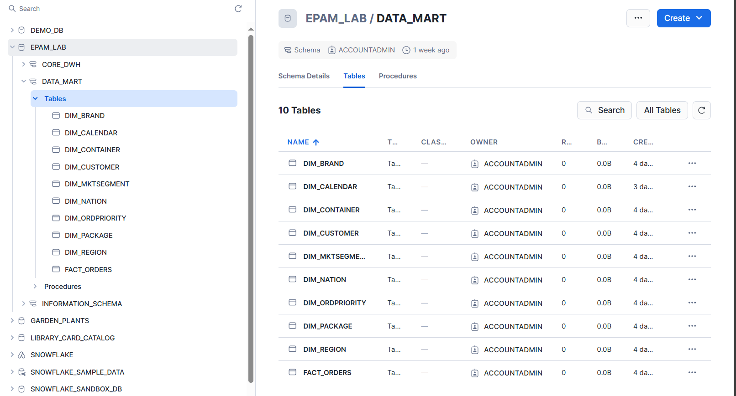

* **Create Stream on table.**

create or replace stream CUST_DELTA_S on table DIM_CUSTOMER;

--slow changing dimension table for Customer

create or replace TABLE EPAM_LAB.DATA_MART.DIM_CUST_UPD

(

C_CUSTKEY NUMBER(38,0),

C_NAME VARCHAR(25),

C_ADDRESS VARCHAR(40),

start_time TIMESTAMP_NTZ,

end_time TIMESTAMP_NTZ,

current_flag INT

);

--Slow Changing Dimension presentation for Customer changes

CREATE OR REPLACE VIEW cust_change_v AS

SELECT c_custkey, c_name, c_address, start_time, end_time, current_flag, dml_type

FROM (

-- Logic for new insertions

SELECT c_custkey, c_name, c_address, update_timestamp AS start_time,

LAG(update_timestamp) OVER (PARTITION BY c_custkey ORDER BY update_timestamp DESC) AS end_time_raw,

CASE

WHEN end_time_raw IS NULL THEN '9999-12-31'::TIMESTAMP_NTZ

ELSE end_time_raw

END AS end_time,

CASE

WHEN end_time_raw IS NULL THEN 1

ELSE 0

END AS current_flag,

'I' AS dml_type

FROM cust_delta_s

WHERE metadata$action = 'INSERT' AND metadata$isupdate = 'FALSE'

UNION ALL

-- Logic for updates

SELECT c_custkey, c_name, c_address, update_timestamp AS start_time,

LAG(update_timestamp) OVER (PARTITION BY c_custkey ORDER BY update_timestamp DESC) AS end_time_raw,

CASE

WHEN end_time_raw IS NULL THEN '9999-12-31'::TIMESTAMP_NTZ

ELSE end_time_raw

END AS end_time,

CASE

WHEN end_time_raw IS NULL THEN 1

ELSE 0

END AS current_flag,

CASE WHEN current_flag = 1 then 'I' else 'U' end AS dml_type

FROM cust_delta_s

WHERE metadata$isupdate = 'TRUE'

UNION ALL

-- Logic for deletions

SELECT c_custkey, c_name, c_address, start_time, CURRENT_TIMESTAMP()::TIMESTAMP_NTZ end_time_raw,

end_time_raw end_time, null current_flag, 'D' AS dml_type

FROM dim_cust_upd h

WHERE h.c_custkey IN (SELECT DISTINCT c_custkey FROM cust_delta_s

WHERE metadata$action = 'DELETE'

AND metadata$isupdate = 'FALSE')

AND h.current_flag = 1

);

CREATE OR REPLACE TASK dim_cust_upd_scd

WAREHOUSE = compute_wh

SCHEDULE = '5 minutes'

WHEN SYSTEM$STREAM_HAS_DATA('cust_delta_s')

AS

MERGE INTO dim_cust_upd h

USING cust_change_v cd ON h.c_custkey = cd.c_custkey

AND h.start_time = cd.start_time

WHEN MATCHED AND cd.dml_type = 'U'

THEN UPDATE

SET h.end_time = cd.end_time,

h.current_flag = 0

WHEN MATCHED AND cd.dml_type = 'D'

THEN UPDATE

SET h.end_time = cd.end_time,

h.current_flag = 0

WHEN NOT MATCHED AND cd.dml_type = 'I'

THEN INSERT (c_custkey, c_name, c_address, start_time, end_time, current_flag)

VALUES (cd.c_custkey, cd.c_name, cd.c_address, cd.start_time, cd.end_time,

cd.current_flag);

--Check stream

insert into DIM_CUSTOMER (C_CUSTKEY, C_NAME, C_ADDRESS) values (11, 'Cust 11', 'addr');

insert into DIM_CUSTOMER (C_CUSTKEY, C_NAME, C_ADDRESS) values (12, 'Cust 12', 'addr');

insert into DIM_CUSTOMER (C_CUSTKEY, C_NAME, C_ADDRESS) values (13, 'Cust 13', 'addr');

select * from cust_delta_s;

select * from cust_change_v;

ALTER TASK IF EXISTS dim_cust_upd_scd RESUME;

select * from dim_cust_upd

order by c_custkey;

select top 10 * from DIM_CUSTOMER;

update dim_customer

set c_address = 'new address is 11', update_timestamp = CURRENT_TIMESTAMP()::TIMESTAMP_LTZ

where c_custkey = 11;

delete from dim_customer

where c_custkey = 12;

select * from cust_delta_s;

select * from cust_change_v;

select * from dim_cust_upd order by c_custkey;

truncate table dim_customer;

* **Create DataMart loading procedures.**

use schema data_mart;

create or replace procedure sp_truncate_dtmart()

returns integer not null

language sql

as

$$

begin

TRUNCATE TABLE EPAM_LAB.DATA_MART.DIM_NATION;

TRUNCATE TABLE EPAM_LAB.DATA_MART.DIM_REGION;

TRUNCATE TABLE EPAM_LAB.DATA_MART.DIM_MKTSEGMENT;;

TRUNCATE TABLE EPAM_LAB.DATA_MART.DIM_CALENDAR;

TRUNCATE TABLE EPAM_LAB.DATA_MART.DIM_CUSTOMER;

TRUNCATE TABLE EPAM_LAB.DATA_MART.DIM_PACKAGE;

TRUNCATE TABLE EPAM_LAB.DATA_MART.DIM_CONTAINER;

TRUNCATE TABLE EPAM_LAB.DATA_MART.DIM_ORDPRIORITY;

TRUNCATE TABLE EPAM_LAB.DATA_MART.DIM_BRAND;

TRUNCATE TABLE EPAM_LAB.DATA_MART.FACT_ORDERS;

end;

$$;

create or replace procedure sp_load_calendar()

returns integer not null

language sql

as

$$

begin

insert into dim_calendar

with period as

(

select min(iff(l_orderkey is null, o_orderdate,

least(o_orderdate, l_shipdate, l_receiptdate))) start_date,

max(iff(l_orderkey is null, o_orderdate,

greatest(o_orderdate, l_shipdate, l_receiptdate))) end_date

from epam_lab.core_dwh.orders

left join epam_lab.core_dwh.lineitem

on l_orderkey = o_orderkey

)

select

to_char(date(start_date) + value::int, 'yyyymmdd') c_calnkey,

date(start_date) + value::int as c_calndate,

year(c_calndate) c_yearnum,

quarter(c_calndate) c_quarter,

month(c_calndate) c_monthnum,

monthname(c_calndate) c_monthname,

week(c_calndate) c_weeknum,

day(c_calndate) c_dayweek,

dayname(c_calndate) c_dayname

from period,

table(flatten(array_generate_range(0, datediff('day', start_date, end_date) + 1)))

order by c_calndate;

return SQLROWCOUNT;

end;

$$;

create or replace procedure sp_load_dim()

returns integer not null

language sql

as

$$

declare

row_count INTEGER DEFAULT 0;

begin

insert into dim_mktsegment

select * from epam_lab.core_dwh.mktsegment;

row_count := row_count + SQLROWCOUNT;

insert into dim_brand

select * from epam_lab.core_dwh.brand;

row_count := row_count + SQLROWCOUNT;

insert into dim_package

select * from epam_lab.core_dwh.packagetype;

row_count := row_count + SQLROWCOUNT;

insert into dim_container

select * from epam_lab.core_dwh.container;

row_count := row_count + SQLROWCOUNT;

insert into dim_nation

select * from epam_lab.core_dwh.nation;

row_count := row_count + SQLROWCOUNT;

insert into dim_region

select * from epam_lab.core_dwh.region;

row_count := row_count + SQLROWCOUNT;

insert into dim_ordpriority

select * from epam_lab.core_dwh.ordpriority;

row_count := row_count + SQLROWCOUNT;

insert into dim_customer (c_custkey, c_name, c_address)

select c_custkey, c_name, c_address

from epam_lab.core_dwh.customer;

row_count := row_count + SQLROWCOUNT;

return row_count;

end;

$$;

create or replace procedure sp_load_facts()

returns integer not null

language sql

as

$$

begin

insert into epam_lab.data_mart.fact_orders

select

c_custkey,

c_segmentkey,

c_nationkey,

r1.r_regionkey c_regionkey,

o_orderkey,

--o_orderdate,

to_char(o_orderdate, 'yyyymmdd')::int o_orddtkey,

o_prioritykey,

o_shippriority,

--l_shipdate,

to_char(l_shipdate , 'yyyymmdd')::int l_shpdtkey,

l_shipmode,

--l_receiptdate,

to_char(l_receiptdate , 'yyyymmdd')::int l_recdtkey,

to_char(l_commitdate, 'yyyymmdd')::int l_comdtkey,

l_extendedprice,

l_discount,

l_quantity,

l_returnflag,

l_linestatus,

s_nationkey,

r2.r_regionkey s_regionkey,

p_brandkey,

p_pcktpkey,

p_cntnrkey,

p_size

from

epam_lab.core_dwh.customer,

epam_lab.core_dwh.orders,

epam_lab.core_dwh.lineitem,

epam_lab.core_dwh.supplier,

epam_lab.core_dwh.part,

epam_lab.core_dwh.nation n1,

epam_lab.core_dwh.nation n2,

epam_lab.core_dwh.region r1,

epam_lab.core_dwh.region r2

where

c_custkey = o_custkey

and l_orderkey = o_orderkey

and l_suppkey = s_suppkey

and p_partkey = l_partkey

and c_nationkey = n1.n_nationkey

and n1.n_regionkey = r1.r_regionkey

and s_nationkey = n2.n_nationkey

and n2.n_regionkey = r2.r_regionkey;

return SQLROWCOUNT;

end;

$$;

* **Datamart Loading.**

use schema data_mart;

call sp_truncate_dtmart();

call sp_load_calendar();

call sp_load_dim();

call sp_load_facts();

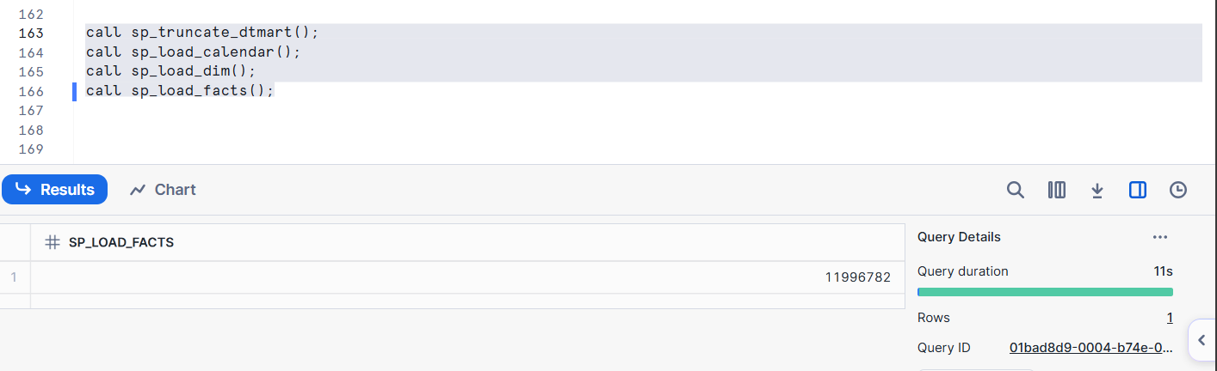

* **Create loading/truncate tasks.**

**--For CORE_DWH**

use schema core_dwh;

CREATE OR REPLACE TASK load_epam_lab_core_dw

USER_TASK_MANAGED_INITIAL_WAREHOUSE_SIZE = 'XSMALL'

SCHEDULE = 'USING CRON 0 11 * * * Europe/London'

AS

begin

call sp_truncate_tables();

call sp_load_region();

call sp_load_nation();

call sp_load_view(

table_name => 'supplier',

view_name => 'h_supplier_v');

call sp_load_customer();

call sp_load_order();

call sp_load_view(

table_name => 'lineitem',

view_name => 'h_lineitem_v');

call sp_load_view(

table_name => 'partsupp',

view_name => 'h_partsupp_v');

call sp_load_part();

end;

CREATE OR REPLACE TASK clear_epam_lab_stage

USER_TASK_MANAGED_INITIAL_WAREHOUSE_SIZE = 'XSMALL'

SCHEDULE = 'USING CRON 0 20 * * * Europe/London'

AS

remove @EPAM_LAB_STAGE;

CREATE OR REPLACE TASK clear_epam_lab_tables

USER_TASK_MANAGED_INITIAL_WAREHOUSE_SIZE = 'XSMALL'

SCHEDULE = 'USING CRON 0 21 * * * Europe/London'

AS

call sp_truncate_tables();

**--For DATA_MART**

use schema data_mart;

CREATE OR REPLACE TASK load_epam_lab_data_mart

USER_TASK_MANAGED_INITIAL_WAREHOUSE_SIZE = 'XSMALL'

SCHEDULE = 'USING CRON 15 11 * * * Europe/London'

AS

begin

call sp_load_calendar();

call sp_load_dim();

call sp_load_facts();

end;

CREATE OR REPLACE TASK clear_epam_lab_dtmart

USER_TASK_MANAGED_INITIAL_WAREHOUSE_SIZE = 'XSMALL'

SCHEDULE = 'USING CRON 0 21 * * * Europe/London'

AS

call sp_truncate_dtmart();

## Snowflake & 3rd party tools

No ability to install third party tools in LSEG laptop! Prohibited by LSEG Policy.

## Snowflake SQL

* **Create several warehouses of different sizes and compare their performance**

use database snowflake_sample_data;

use schema tpch_sf100;

use warehouse compute_wh;

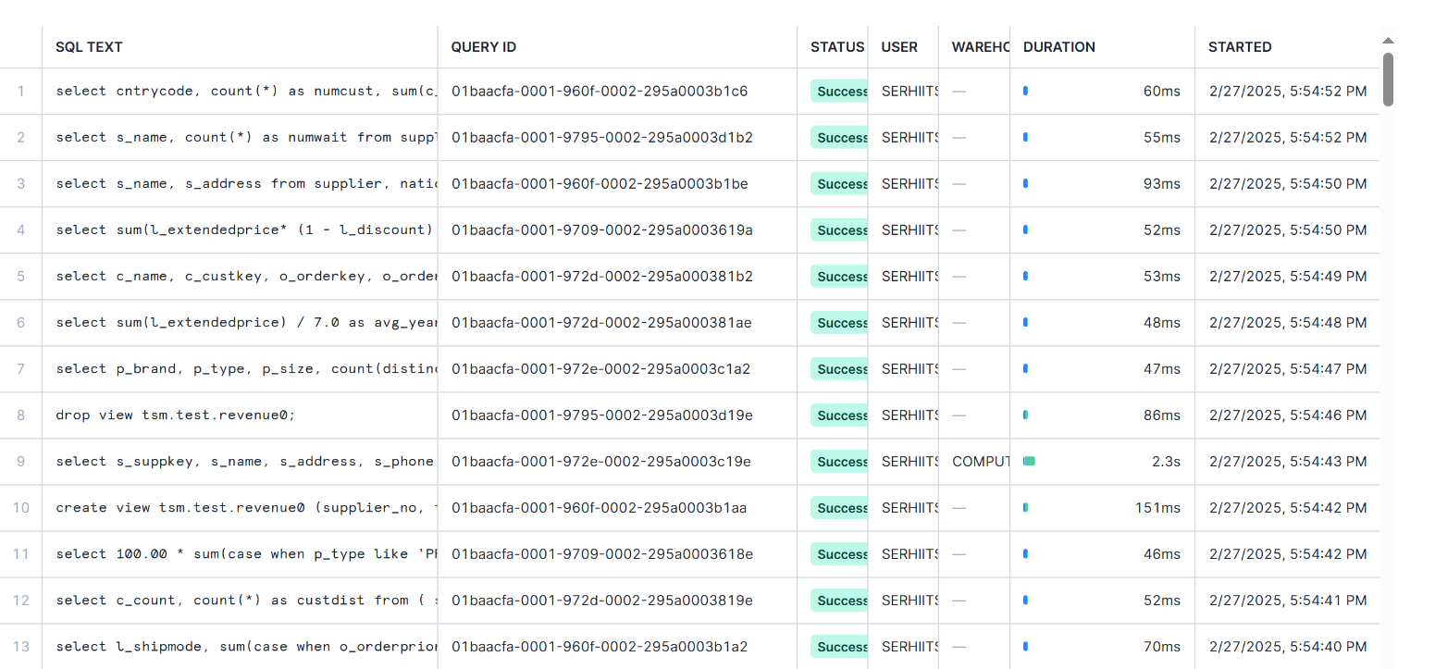

use database snowflake_sample_data;

use schema tpch_sf100;

use warehouse testsmall_wh;

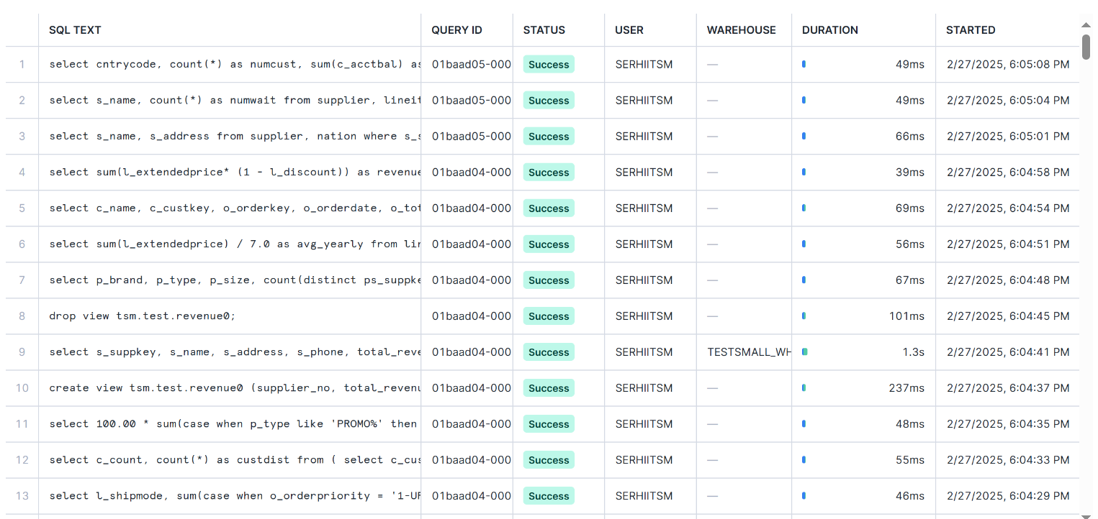

use database snowflake_sample_data;

use schema tpch_sf100;

use warehouse testmedium_wh;

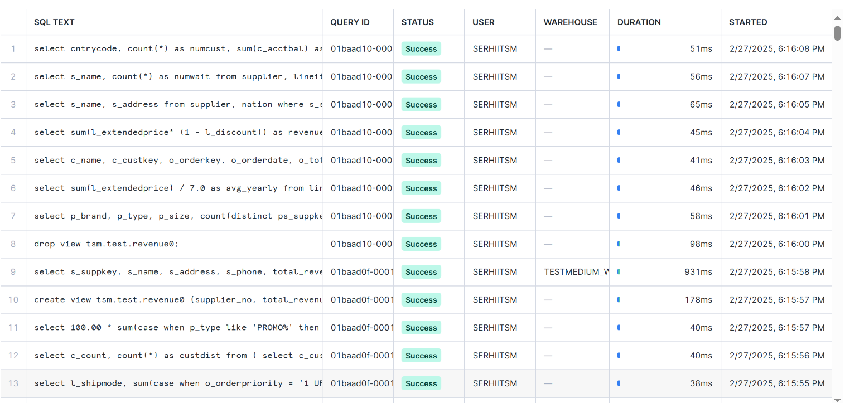

* **Test how Snowflake leverages different types of cash.**

--Sql query for testing

select cntrycode,

count(*) as numcust,

sum(c_acctbal) as totacctbal

from ( select substring(c_phone, 1, 2) as cntrycode,

c_acctbal

from customer

where substring(c_phone, 1, 2) in

('14', '21', '24', '33', '28', '17', '10')

and c_acctbal > (

select avg(c_acctbal)

from customer

where c_acctbal > 0.00

and substring(c_phone, 1, 2) in

('14', '21', '24', '33', '28', '17', '10')

)

and not exists (

select * from orders

where o_custkey = c_custkey)

) as custsale

group by cntrycode

order by cntrycode;

ALTER SESSION SET USE_CACHED_RESULT = FALSE;

ALTER WAREHOUSE COMPUTE_WH SUSPEND;

ALTER SESSION SET USE_CACHED_RESULT = TRUE;

ALTER SESSION SET USE_CACHED_RESULT = FALSE;

* **Rewrite a couple of queries to execute on the Start Schema data model and compare performance (3NF vs Star Schema).**

**--Query 1 in CORE_DWH**

select l_orderkey odrerkey,

sum(l_extendedprice * (1 - l_discount)) as revenue,

o_orderdate orderdate,

o_shippriority shippriority

from epam_lab.core_dwh.customer,

epam_lab.core_dwh.orders,

epam_lab.core_dwh.lineitem,

epam_lab.core_dwh.mktsegment

where c_custkey = o_custkey

and l_orderkey = o_orderkey

and m_segmentkey = c_segmentkey

and o_orderdate < date '1995-03-01'

and l_shipdate > date '1995-03-01'

and m_segmentname = 'AUTOMOBILE'

group by l_orderkey, o_orderdate, o_shippriority

order by revenue desc, orderdate;

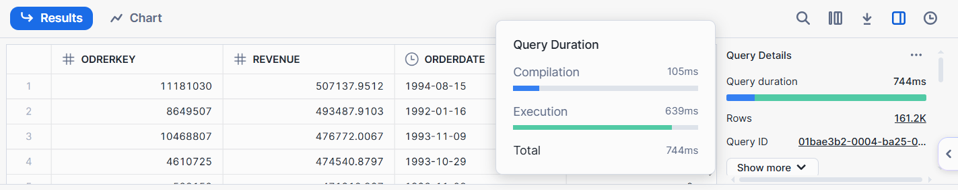

**--Query 1 in DATA_MART**

select o_orderkey l_orderkey,

sum(l_extendedprice * (1 - l_discount)) as revenue,

c1.c_calndate o_orderdate,

o_shippriority

from fact_orders f,

dim_calendar c1,

dim_mktsegment

where o_orddtkey = c1.c_calnkey

and o_orddtkey < 19950301

and l_shpdtkey > 19950301

and m_segmentkey = c_segmentkey

and m_segmentname = 'AUTOMOBILE'

group by l_orderkey, o_orderdate, o_shippriority

order by revenue desc, o_orderdate;

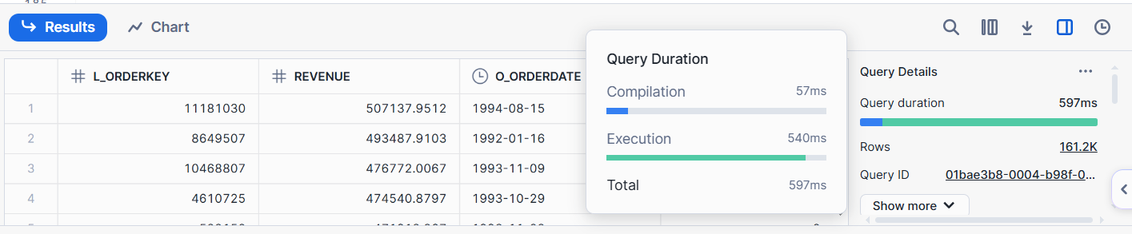

**--Query 2 in CORE_DWH**

select p_priorityname o_orderpriority,

count(*) as order_count

from epam_lab.core_dwh.orders,

epam_lab.core_dwh.ordpriority

where o_orderdate >= date '1993-10-01'

and p_prioritykey = o_prioritykey

and o_orderdate < add_months(date '1993-10-01',3)

and exists (

select * from epam_lab.core_dwh.lineitem

where l_orderkey = o_orderkey

and l_commitdate < l_receiptdate

)

group by o_orderpriority

order by o_orderpriority;

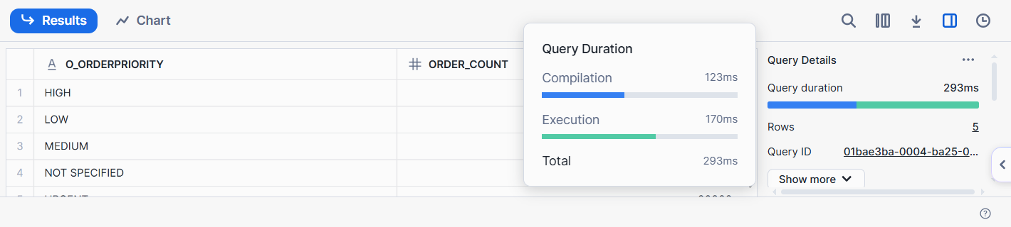

**--Query 2 in DATA_MART**

select p_priorityname o_orderpriority,

count(*) as order_count

from fact_orders, dim_calendar, dim_ordpriority

where o_orddtkey = c_calnkey

and c_yearnum = 1993 and c_quarter = 4

and l_comdtkey < l_recdtkey

and p_prioritykey = o_prioritykey

group by o_orderpriority

order by o_orderpriority;

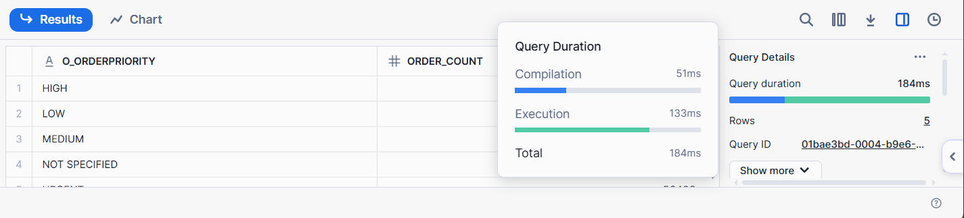

**--Query 3 in CORE_DWH**

select n_name,

sum(l_extendedprice * (1 - l_discount)) as revenue

from epam_lab.core_dwh.customer,

epam_lab.core_dwh.orders,

epam_lab.core_dwh.lineitem,

epam_lab.core_dwh.supplier,

epam_lab.core_dwh.nation,

epam_lab.core_dwh.region

where c_custkey = o_custkey

and l_orderkey = o_orderkey

and o_orderdate >= date '1997-01-01'

and o_orderdate < add_months(date '1997-01-01',12)

and l_suppkey = s_suppkey

and c_nationkey = s_nationkey

and s_nationkey = n_nationkey

and n_regionkey = r_regionkey

and r_name = 'EUROPE'

group by n_name

order by revenue desc;

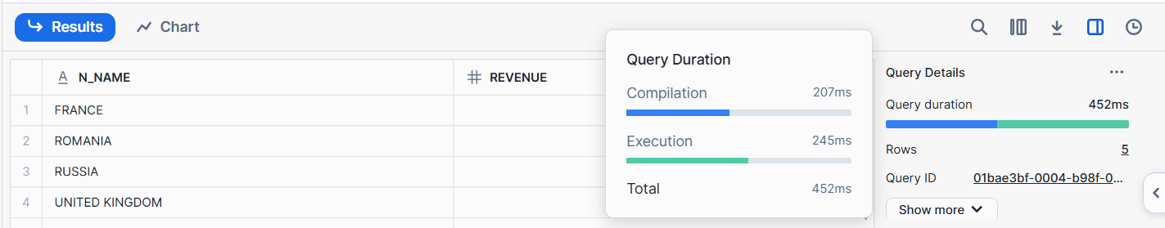

**--Query 3 in DATA_MART**

select n_name,

sum(l_extendedprice * (1 - l_discount)) as revenue

from fact_orders, dim_calendar, dim_region, dim_nation

where o_orddtkey = c_calnkey

and r_regionkey = s_regionkey

and c_nationkey = s_nationkey

and s_nationkey = n_nationkey

and r_name = 'EUROPE'

and c_yearnum = 1997

group by n_name

order by revenue desc;

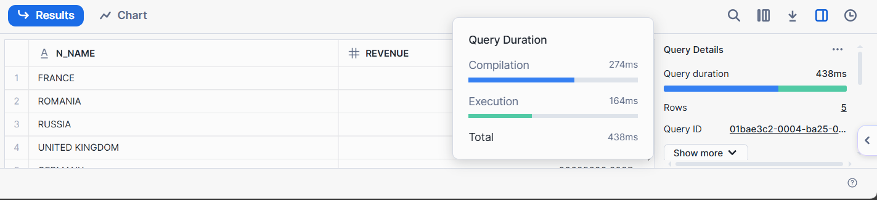

* **Execute queries using SnowSQL (CLI Client).**

tpch_data>snow sql -f sql_query.txt

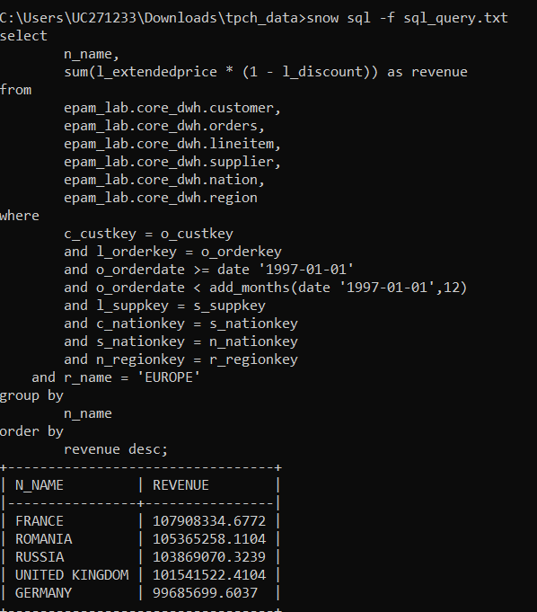

tpch_data>snow sql -q "select c_custkey, c_name, c_address, c_phone from customer where c_custkey between 1 and 20 limit 10;"

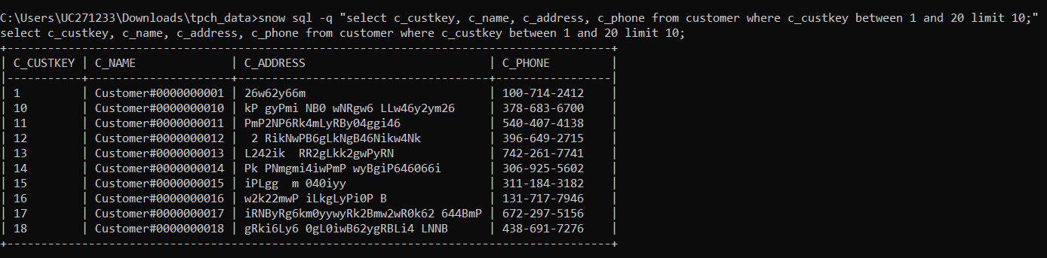

## Other Snowflake features

* **Object Cloning**

CREATE SCHEMA core_dwh_clone CLONE core_dwh;

SELECT GET_DDL ('schema', 'core_dwh_clone', true);

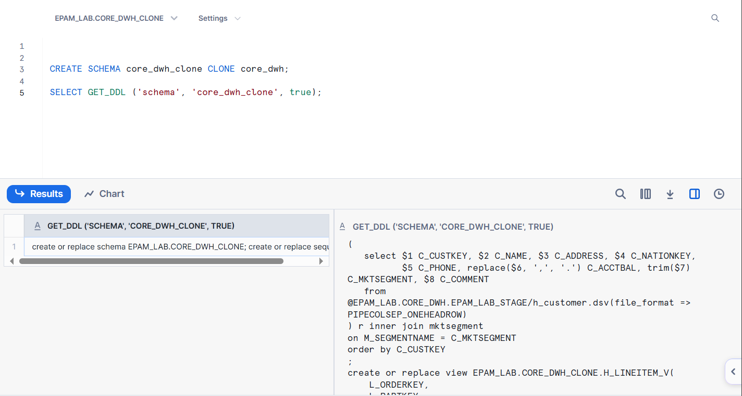

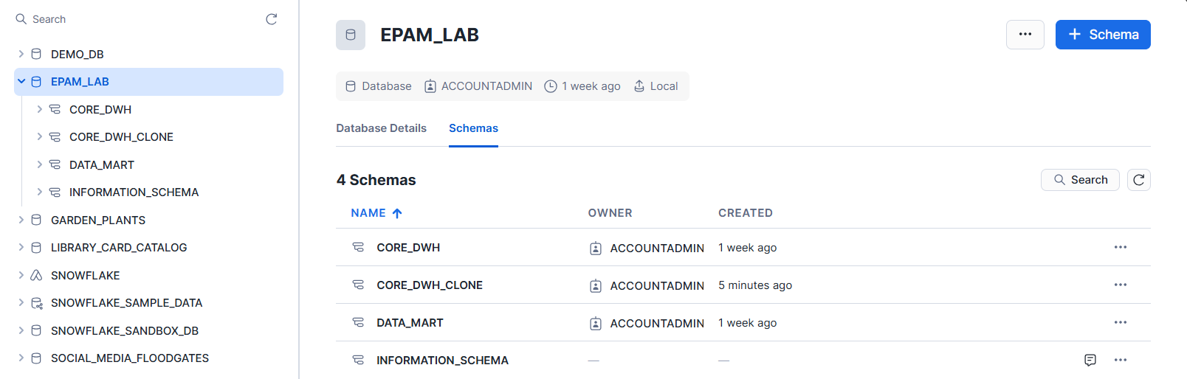

select * from epam_lab.core_dwh.brand

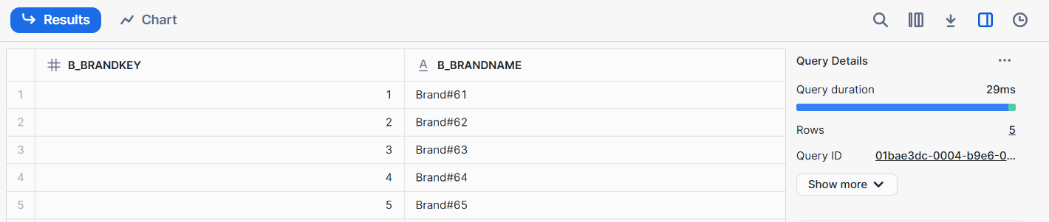

select * from epam_lab.core_dwh_clone.brand

--Chang data in clone schema

insert into epam_lab.core_dwh_clone.brand

values (6, 'Brand#66');

update epam_lab.core_dwh_clone.brand

set b_brandname = 'Brand#11'

where b_brandkey = 1;

update epam_lab.core_dwh_clone.brand

set b_brandname = 'Brand#22'

where b_brandkey = 2;

select * from epam_lab.core_dwh_clone.brand

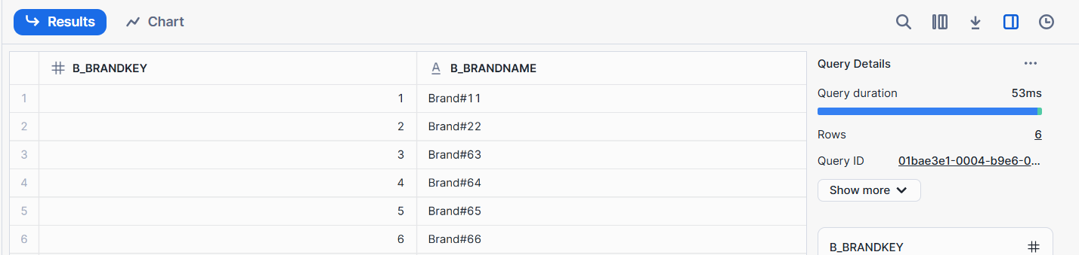

--Data is not changed in source.

select * from epam_lab.core_dwh.brand;

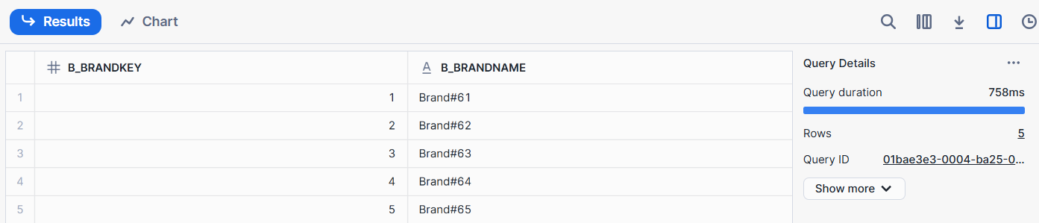

--Add a new record in source.

insert into epam_lab.core_dwh.brand

values (7, 'Brand#77');

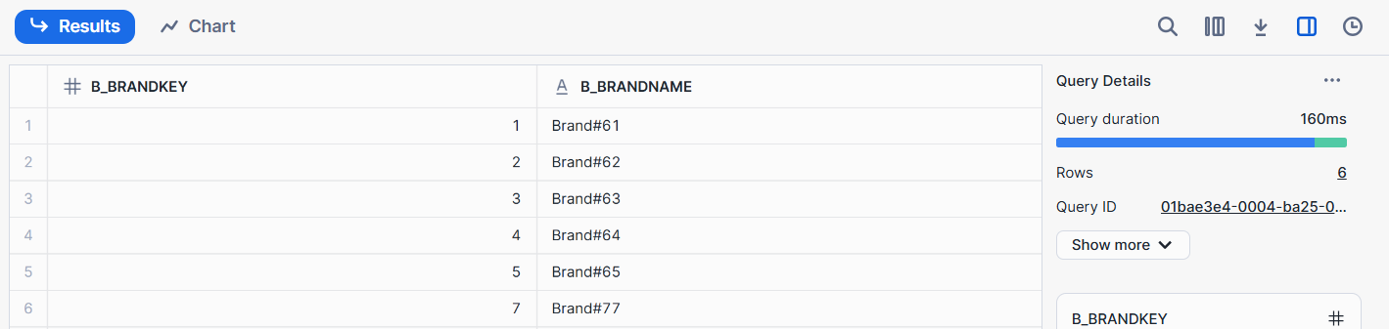

select * from epam_lab.core_dwh_clone.brand;

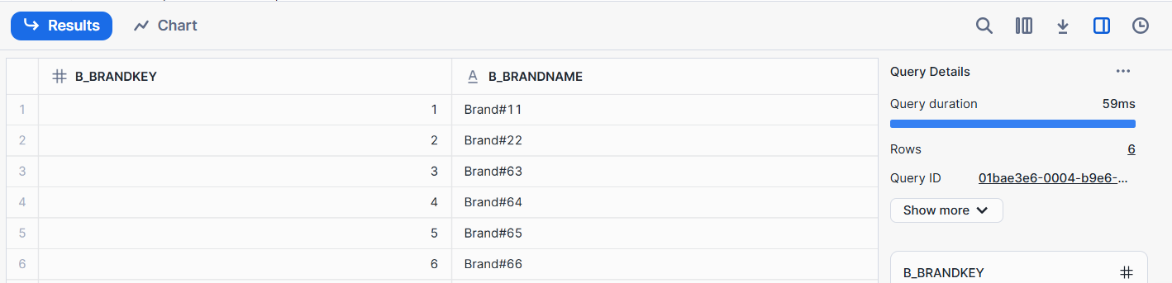

* **Time travel**

ALTER TABLE epam_lab.core_dwh.region SET DATA_RETENTION_TIME_IN_DAYS=1;

select * from epam_lab.core_dwh.region;

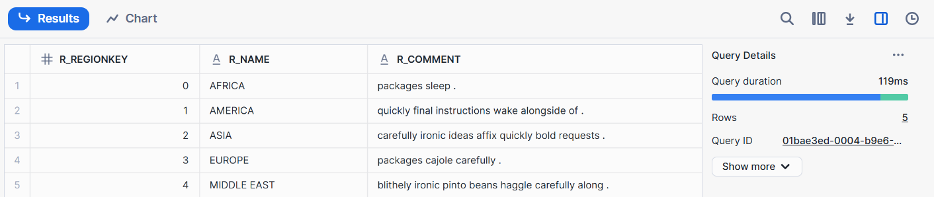

insert into epam_lab.core_dwh.region values (5, 'Test', 'Test purpose');

update epam_lab.core_dwh.region

set R_NAME = 'Africa' where r_regionkey = 0;

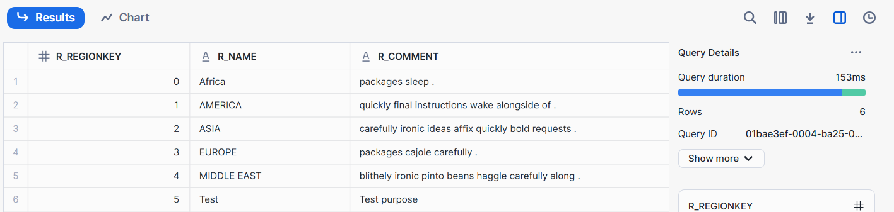

select getdate() -- 2025-03-09 03:24:35.849 -0700

SELECT * FROM epam_lab.core_dwh.region BEFORE(TIMESTAMP => '2025-03-09 03:10:35.849 -0700'::timestamp_tz);

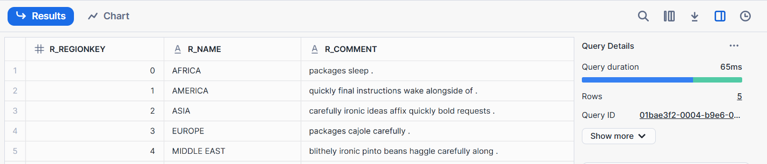

SELECT * FROM epam_lab.core_dwh.region AT(OFFSET => -60*11);

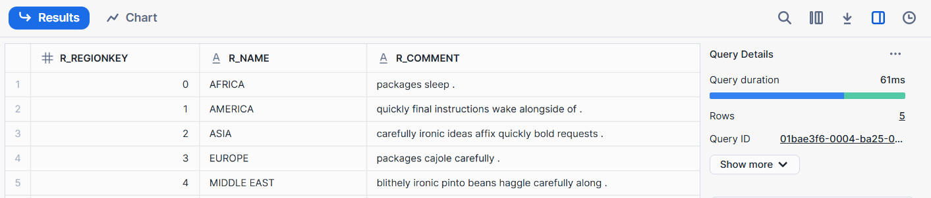

SELECT * FROM epam_lab.core_dwh.region AT(OFFSET => -60*8);

* **Data Sharing**

use role accountadmin;

create or replace share epam_lab_demo;

grant usage on database epam_lab to share epam_lab_demo;

grant usage on schema epam_lab.data_mart to share epam_lab_demo;

grant select on all tables in schema epam_lab.data_mart to share epam_lab_demo;

alter share epam_lab_demo add accounts = RWXFUUQ.YZ51351;

--Consumer

use role accountadmin;

show shares;

create database epam_lab_demo from share SYNHUMY.ZBB74720;

## Snowpipe

create or replace TABLE TSM.TEST.PIPE_TEST (

ID NUMBER(5,0),

NAME VARCHAR(80),

SEGMENT NUMBER(5,0)

);

create or replace file format PIPECOLSEP_ONEHEADROW

type = 'CSV'

field_delimiter = '|'

skip_header = 1

field_optionally_enclosed_by = '"'

trim_space = TRUE;

create or replace storage integration snowpipe_az_integration

type = external_stage

storage_provider = azure

enabled = true

azure_tenant_id = '04e2f439-5688-41cd-85df-92711afd2dcc'

storage_allowed_locations = ('azure://tsmstoragepipe.blob.core.windows.net/ordercsv');

desc storage integration snowpipe_az_integration;

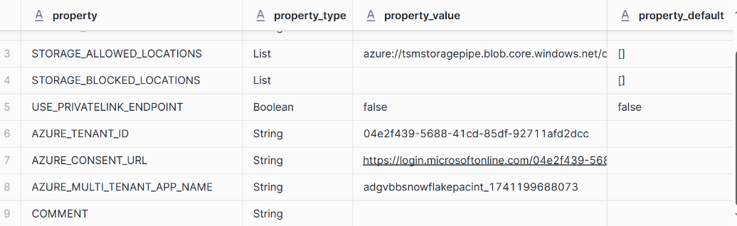

create or replace stage az_stage

storage_integration = snowpipe_az_integration

url = 'azure://tsmstoragepipe.blob.core.windows.net/ordercsv'

file_format = ( format_name=PIPECOLSEP_ONEHEADROW );

describe stage az_stage;

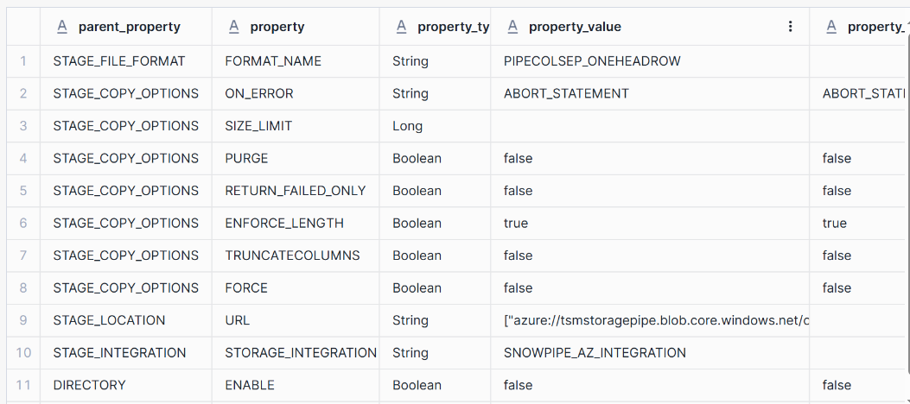

CREATE OR REPLACE NOTIFICATION INTEGRATION snowpipe_event

ENABLED = TRUE

TYPE = QUEUE

NOTIFICATION_PROVIDER = AZURE_STORAGE_QUEUE

AZURE_STORAGE_QUEUE_PRIMARY_URI = 'https://tsmstoragepipe.queue.core.windows.net/snowpipequeue'

AZURE_TENANT_ID = '04e2f439-5688-41cd-85df-92711afd2dcc';

DESCRIBE NOTIFICATION INTEGRATION snowpipe_event;

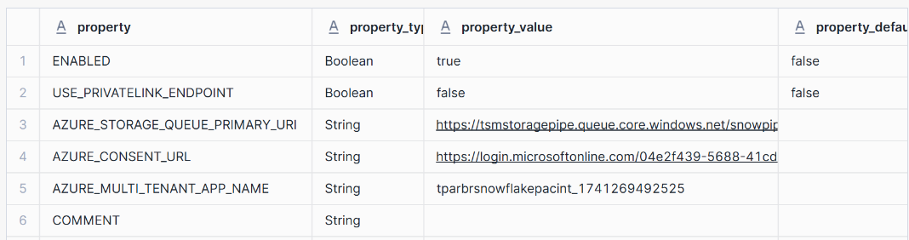

CREATE or replace PIPE test_pipe

auto_ingest = true integration = 'SNOWPIPE_EVENT'

AS

COPY INTO tsm.test.pipe_test

FROM @az_stage

FILE_FORMAT = ( format_name=PIPECOLSEP_ONEHEADROW );

SELECT SYSTEM$PIPE_STATUS('test_pipe');

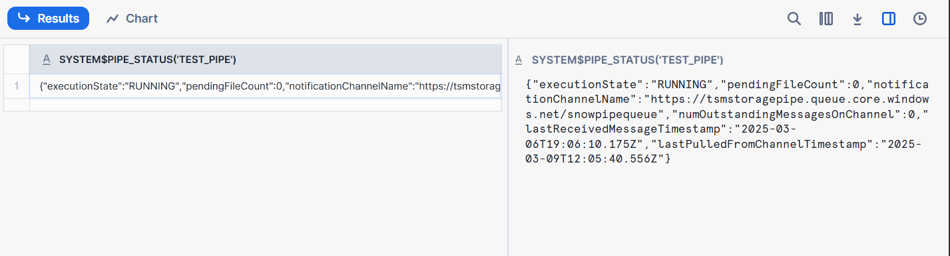

--Uploaded file test1.csv

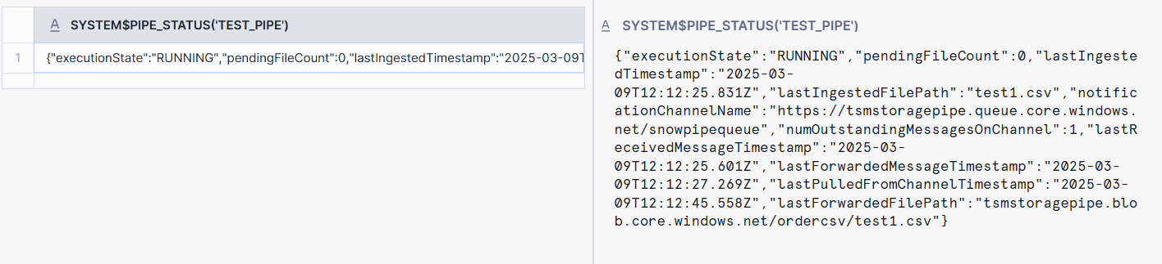

select * from tsm.test.pipe_test;

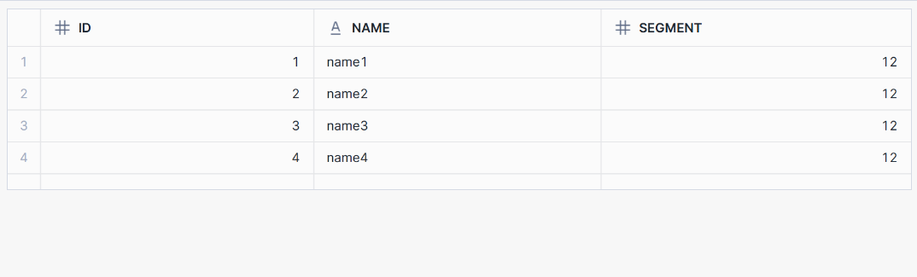

--Uploaded file test2.csv

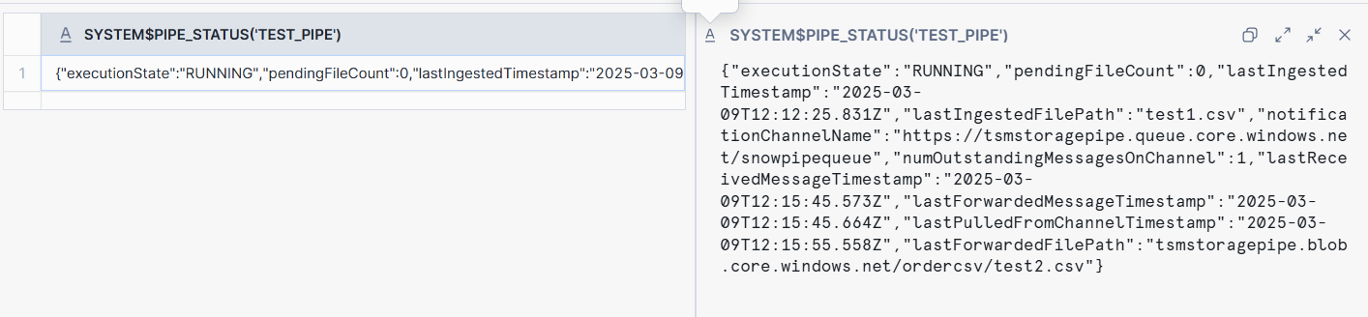

select * from tsm.test.pipe_test;

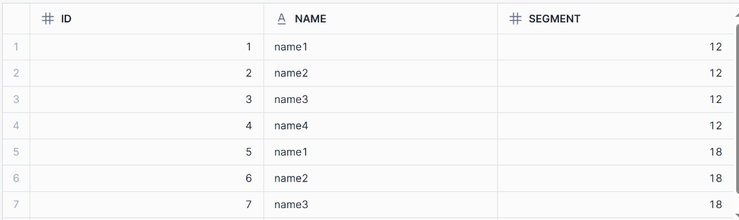

list @az_stage;

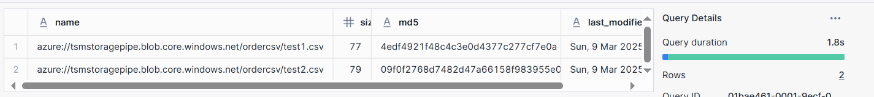

select $1, $2, $3 from @az_stage;



